\
GP Term 4 2014 – Comprehension – Lesson 1 – Culture – Cultural Heritage

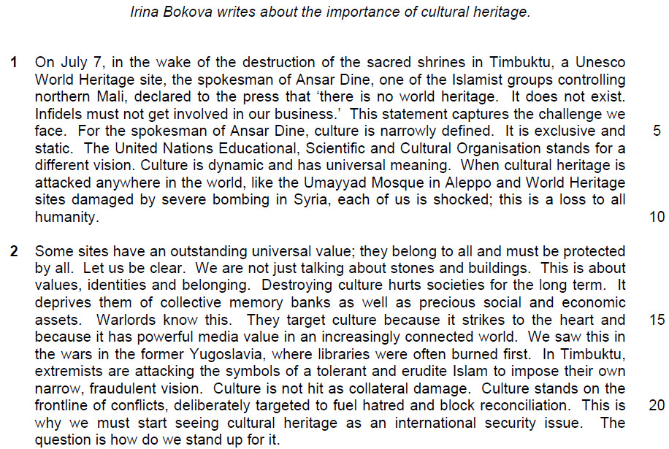

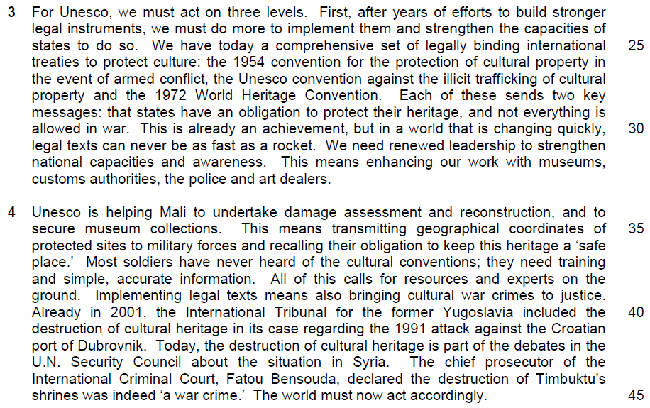

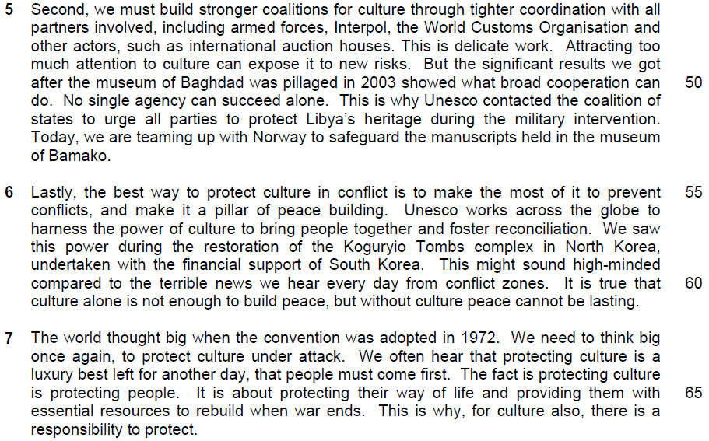

1. What is the author’s purpose in beginning with the quote from the spokesman of Ansar dine (lines 3-4)?

…………………………………………………………………………………………..
…………………………………………………………………………………………..

……………………………………………………………………………………...…..

……………………………………………………………………………………...…..

……………………………………………………………………………………….[1]

2. In paragraph 1, what contrast does the author make between the United Nation’s vision of culture and that of Ansar Dine? Use your own words as far as possible.

…………………………………………………………………………………………..
…………………………………………………………………………………………..

……………………………………………………………………………………...…..

……………………………………………………………………………………...…..

……………………………………………………………………………………….[2]

3. What does that author imply by using the words ‘not just’ to explain the value of cultural sites (line 12)? Use your own words as far as possible.

…………………………………………………………………………………………..
…………………………………………………………………………………………..

……………………………………………………………………………………...…..

……………………………………………………………………………………...…..

……………………………………………………………………………………….[2]

4. Explain what is lost when ‘collective memory banks’ are destroyed (line 14).

…………………………………………………………………………………………..
…………………………………………………………………………………………..

……………………………………………………………………………………...…..

……………………………………………………………………………………...…..

……………………………………………………………………………………….[2]

5. What is the author implying when she says that warlords’ target culture because it strikes to the heart’ (line 15)

…………………………………………………………………………………………..
…………………………………………………………………………………………..

……………………………………………………………………………………...…..

……………………………………………………………………………………...…..

……………………………………………………………………………………….[2]

6. Explain and explain how one example of the author’s use of language in lines 18-19 reflects her overall bias.

…………………………………………………………………………………………..
…………………………………………………………………………………………..

……………………………………………………………………………………...…..

……………………………………………………………………………………...…..

……………………………………………………………………………………….[1]

7. Explain what the author means by saying that targeting culture can ‘fuel hatred and block reconciliation’ (line 20)? Use your own words as far as possible.

…………………………………………………………………………………………..
…………………………………………………………………………………………..

……………………………………………………………………………………...…..

……………………………………………………………………………………...…..

……………………………………………………………………………………….[2]

8. Using material from paragraphs 3-5 only, summarise what the author has to say about what everyone needs to do to protect cultural sites and how to go about doing so.

Write your summary in no more than 120 words, not counting the opening words which are printed below. Use your own words as far as possible.

To protect cultural sites, we must…

…………………………………………………………………………………………..
…………………………………………………………………………………………..

……………………………………………………………………………………...…..

…………………………………………………………………………………………..
…………………………………………………………………………………………..

……………………………………………………………………………………...…..

…………………………………………………………………………………………..
…………………………………………………………………………………………..

……………………………………………………………………………………...…..

…………………………………………………………………………………………..
…………………………………………………………………………………………..

……………………………………………………………………………………...…..

…………………………………………………………………………………………..
…………………………………………………………………………………………..

……………………………………………………………………………………...…..

…………………………………………………………………………………………..
…………………………………………………………………………………………..

…………………………………………………………………………………………..
…………………………………………………………………………………………..

……………………………………………………………………………………...…..

…………………………………………………………………………………………..
…………………………………………………………………………………………..

…………………………………………………………………………………….....[8]

9. In paragraph 6, who might dismiss the author’s argument about the need to protect culture in conflict?

…………………………………………………………………………………………..
…………………………………………………………………………………………..

……………………………………………………………………………………...…..

……………………………………………………………………………………...…..

……………………………………………………………………………………….[1]

10. In paragraph 7, what does the author suggest would be lost if we fail to protect culture? Use your own words as far as possible.

…………………………………………………………………………………………..
…………………………………………………………………………………………..

……………………………………………………………………………………...…..

……………………………………………………………………………………...…..

……………………………………………………………………………………….[2]

11. Why does the author keep repeating the words ‘protect’ and ‘protecting’ in the last paragraph?

…………………………………………………………………………………………..
…………………………………………………………………………………………..

……………………………………………………………………………………...…..

……………………………………………………………………………………...…..

……………………………………………………………………………………….[2]

11. Irina Bokva feels that cultural heritage belongs to all and must be protected by all. To what extent do you agree or disagree with her views? How applicable do you find her observations to yourself and your own society?

…………………………………………………………………………………………..
…………………………………………………………………………………………..
…………………………………………………………………………………………..
…………………………………………………………………………………………..
…………………………………………………………………………………………..
…………………………………………………………………………………………..
…………………………………………………………………………………………..
…………………………………………………………………………………………..
…………………………………………………………………………………………..
…………………………………………………………………………………………..
…………………………………………………………………………………………..
…………………………………………………………………………………………..
…………………………………………………………………………………………..
…………………………………………………………………………………………..
…………………………………………………………………………………………..
…………………………………………………………………………………………..
…………………………………………………………………………………………..
…………………………………………………………………………………………..
…………………………………………………………………………………………..
…………………………………………………………………………………………..

…………………………………………………………………………………………..
…………………………………………………………………………………………..
…………………………………………………………………………………………..
…………………………………………………………………………………………..
…………………………………………………………………………………………..
…………………………………………………………………………………………..
…………………………………………………………………………………………..
…………………………………………………………………………………………..
…………………………………………………………………………………………..
…………………………………………………………………………………………..
…………………………………………………………………………………………..
…………………………………………………………………………………………..
…………………………………………………………………………………………..
…………………………………………………………………………………………..
…………………………………………………………………………………………..
…………………………………………………………………………………………..
…………………………………………………………………………………………..
…………………………………………………………………………………………..
…………………………………………………………………………………………..
…………………………………………………………………………………………..
…………………………………………………………………………………………..
…………………………………………………………………………………………..
…………………………………………………………………………………………..
…………………………………………………………………………………………..

…………………………………………………………………………………………..
…………………………………………………………………………………………..
…………………………………………………………………………………………..
…………………………………………………………………………………………..
…………………………………………………………………………………………..
…………………………………………………………………………………………..
…………………………………………………………………………………………..
…………………………………………………………………………………………..
…………………………………………………………………………………………..
…………………………………………………………………………………………..
…………………………………………………………………………………………..
…………………………………………………………………………………………..
…………………………………………………………………………………………..
…………………………………………………………………………………………..
…………………………………………………………………………………………..
…………………………………………………………………………………………..
…………………………………………………………………………………………..
…………………………………………………………………………………………..
…………………………………………………………………………………………..
…………………………………………………………………………………………..
…………………………………………………………………………………………..
…………………………………………………………………………………….[8]

Suggested Answers

1) What is the author's purpose in beginning with the quote from the spokesman of Ansar Dine (lines 3-4)? (1)

Quotes
a. 'there is no world heritage. It does not exist. Infidels must not get involved in our business'

OR
b.
This statement captures the challenge we face

Paraphrased
a. Her purpose is to create a negative impression of people who think in this narrow fashion /are so intolerant / to immediately elicit sympathy for her cause by presenting the opposition as fanatical

OR
b. She feels his view summarises /encapsulates / best expresses the kind of thinking she / Unesco is trying to overcome / has to change / the difficulties faced by those trying to preserve culture/problem about cultural preservation

2) In paragraph 1, what contrast does the author make between the United Nation's vision of culture and that of Ansar Dine? Use your own words as far as possible. (2)

Quotes
1a.[culture] has universal meaning ...[when cultural heritage is attacked] this is a loss to all humanity

1b. Narrowly defined ... exclusive

2a.culture is dynamic

2b. and static

Paraphrased
1a.[UN] Culture belongs to / influences /affects all of us / all culture has significance / importance for all human beings / mankind/ everyone is able to relate to culture and understand it.

1b.[AD] It only belongs to / is owned by /is the property of a single group / one people / country / place / civilisation / not inclusive to a specific community.

2a. [UN] It is fluid / evolves / develops /progresses /changes in response to changes in us / our way of thinking /perspectives / significantly impacts lives

2b. [AD] It is unchanging / fixed /does not evolve/ rigid/inflexible

3) What does the author imply by using the words 'not just' to explain the value of cultural sites (Iine12)? Use your own words as far as possible. (2)

Quotes
1 .We are not just talking about

2.stones and buildings

3.This is about values

4.ldentities and belonging

Paraphrased
1. The importance of cultural sites does not simply / merely lie / exist / is not limited / restricted to

2. in their physical form / structures /physical objects / their concrete aspects/architecture / external facade/ physical entities/ physical aspects/ physical existence

3. Other factors are / They also express /give form to our ideals / principles / what we believe in / what we consider important/ morals / morals of citizens

4. and give us a sense of who we are /remind us of our common heritage / the communities we are affiliated to / the things we all share / how we all come from the same species/ sense of rootedness/ sense of togetherness/sense of community

4) Explain what is lost when 'collective memory banks' are destroyed (line 14). (2)

Quotes
1.[Destroying culture hurts societies for the long term. It deprives them of] collective

2. memory banks

Paraphrased
1 .What is lost is the sense of togetherness /feeling of oneness with each other that comes from/ social cohesion is lost
OR
What is lost are all the group / community /shared / commonly held

2. remembrances / stored / recorded knowledge that has been passed down for generations / of their traditions / past /achievements / accomplishments / legacy/heritage / precious experiences gathered over many years / reminiscence

5) What is the author implying when she says that warlords' target culture because it strikes to the heart' (line 15)? (2)

Quotes
1 .Warlords ... target culture
2. because it strikes to the heart

Paraphrased
1 .She implies that warlords aim to destroy/ conquer /subjugate / utterly demoralise a people, by destroying their culture

2. because culture comes from / represents the soul of a people/ culture is essential /crucial to a people's identity / survival/causes the most direct and harmful destruction to the people's emotion

6) Identify and explain how one example of the author's use of language in lines 18-19 reflects her overall bias. (1)

Possible choices for identification
A) Negative bias
A1. Extremists
A2. their own narrow vision
A3. fraudulent vision
A4. are attacking
A5. to impose

B) Positive bias
B1. The symbols of tolerant
B2. and erudite Islam

Explanation of bias
A1. Her use of 'extremists' reflects her bias against people whose minds are closed /whom she sees as fanatical / those who do not share her more moderate views their own narrow vision

A2. Her use of 'narrow vision' reflects her bias against people who are unable to see beyond their own parochial interests / who do not have her broader view fraudulent vision

A3. The use of 'fraudulent' to describe their vision shows her bias / prejudice against these people as she feels their views /beliefs are lies / false / distortions of the truth / clash with / go against her own valid/ truthful beliefs are attacking

A4. Her choice of a word that means use of violence / force reflects her view that such people are violent / barbaric/ primitive must resort to force / do not use accepted means to express / propagate their beliefs/ in contrast to her own means which are rational / civilised

A5. Her use of 'impose' reflects her view that such people are violent / barbaric/primitive /must resort to force / do not use accepted means of persuasion / in contrast to her own means which are rational /civilised

B1. Her use of the very positive word 'tolerant' shows her approval of those who value open mindedness / acceptance of others' views as she does

B2. Her use of 'erudite' shows her bias in favour of those she feels love learning / knowledge / understand the importance of collected wisdom as she does

7) Explain what the author means by saying that targeting culture can 'fuel hatred and block reconciliation' (line 20)? Use your own words as far as possible (2)

Quotes
1 . [Targeting culture] can fuel hatred

2. and block

3. reconciliation

Paraphrased
1. This act can cause / provoke deep resentment /feelings of tremendous anger / animosity towards those who do the damage /

2. and can remove virtually all chances /make it next to impossible / extremely improbable for the two groups in conflict /at war / nothing can be done to stop/prevent/ hinder/ obstruct/ impede/ deter/negates opportunities

3. to ever come together / find a peaceful solution for their differences / come to terms with each other / restore their relationship/ being able to forgive/ getting together again/ compromise

8) Using material from paragraphs 3-5 only, summarise what the author has to say about what everyone needs to do to protect cultural sites and how to go about doing so.

Write your summary in no more than 120 words, not counting the opening words which are printed below. Use your own words as far as possible.
To protect cultural sites, we must...
S/N | Lifted | Paraphrased
1. | [First, after years of efforts to build stronger legal instruments] we must do more to implement them (lines 23-24)
2. | and strengthen the capacities of states to do so. (lines 24-25)
3. | We have today a comprehensive set of legally binding international treaties to protect culture… (lines 25-26) Each of these sends two key messages (lines 27-28)
4. | States have an obligation to protect their heritage… (line 29)
5. | and not everything is allowed in war (lines 29-30)
6. | … but in a world changing quickly (line 30)
7. | legal texts can be never be as fast as a rocket. (line 31)
8. | We need renewed leadership (line 31)
9. | to strengthen national capacities (line 31-2)
10. | and awareness. (line 32)
11. | This means enhancing our work with museums, custom authorities, the police and art dealers (lines 32-33)
S/N | Lifted | Paraphrased
12. | This means transmitting geographical coordinates of protected sites to military forces (lines 35-36)
13. | and recalling their obligation to keep this heritage a “safe place” (line 36-37)
14 | Most soldiers have never heard of the cultural conventions; they need training (line 37)
15 | and simple, accurate information. (line 38)
16 | All of this calls for more resources and experts on the ground. (line 38-39)
17 | implementing legal texts means also bringing cultural war crimes to justice. (line 39)
18 | …we must build stronger “coalitions for culture” through tighter coordination with all partners involved… (lines 46-47)
19 | This is delicate work (line 48)
20 | Attracting too much attention to culture can expose it to new risks. (line 48-49)

8) Using material from paragraphs 3-5 only, summarise what the author has to say about what everyone needs to do to protect cultural sites and how to go about doing so.

Write your summary in no more than 120 words, not counting the opening words which are printed below. Use your own words as far as possible.
To protect cultural sites, we must...
S/N | Lifted | Paraphrased
1. | [First, after years of efforts to build stronger legal instruments] we must do more to implement them (lines 23-24) | make more effort to consciously use/apply put into practice the laws we already have
2. | and strengthen the capacities of states to do so. (lines 24-25) | to enhance/intensify the ability of countries to carry out/use them
3. | We have today a comprehensive set of legally binding international treaties to protect culture… (lines 25-26) Each of these sends two key messages (lines 27-28) | Currently, there are global/world-wide agreements to govern/covering the protection of culture that inform/tell/warn
4. | States have an obligation to protect their heritage… (line 29) | countries/nations that they have the duty/responsibility/must be committed to preserving their culture
5. | and not everything is allowed in war (lines 29-30) | and to exercise constraint in times of conflict/battle/that they cannot use an outbreak of hostilities as an excuse to do whatever they wish.
6. | … but in a world changing quickly (line 30) | With the state of flux/uncertainty in the world/with new conflicts breaking out suddenly/unexpectedly
7. | legal texts can be never be as fast as a rocket. (line 31) | laws/policies cannot be constantly updated/laws cannot always keep up with/be enforced at the same speed/as swiftly as violence can break out
8. | We need renewed leadership (line 31) | Thus, it is necessary/essential that those in authority/those at the helm put in more effort/place more importance on/push for more action/improved management/constant political reconfiguration
9. | to strengthen national capacities (line 31-2) | to increase their countries’ ability to protect their heritage/be ready and able to enforce existing laws/improve their own means/methods of protection/new initiatives are necessary to improve countries’ abilities
S/N | Lifted | Paraphrased
10. | and awareness. (line 32) | as well as raise consciousness/knowledge about the issue/the importance of/need to protect culture
11. | This means enhancing our work with museums, custom authorities, the police and art dealers (lines 32-33) | We need to improve our liaisons/work very closely with the various organizations involved/the people responsible for watching over/handling in cultural objects/ protecting culture/experts in relevant fields relevant personnel/stakeholders
12. | This means transmitting geographical coordinates of protected sites to military forces (lines 35-36) | The armed forces need to be informed where these cultural sites are/deployed at identified sites
13. | and recalling their obligation to keep this heritage a “safe place” (line 36-37) | We need to seek the cooperation of/co-opt the army to/impress upon/remind them of their duty/responsibility to provide security/to safeguard/ to not destroy cultural sites
14 | Most soldiers have never heard of the cultural conventions; they need training (line 37) | In order to allow armies/the armed forces to do so effectively, they require coaching/instruction/drilling on how/methods to protect these sites/undertake practice
15 | and simple, accurate information. (line 38) | and be given straightforward/practical/easily applied/factual/correct/up-to-date/ recent data
16 | All of this calls for more resources and experts on the ground. (line 38-39) | This requires/needs/must be backed up by/ there must be sufficient means/capacity/facilities/equipment/useful, materials and specialized personnel/ professionals/specialists
17 | implementing legal texts means also bringing cultural war crimes to justice. (line 39) | In addition, punitive action must be taken against/punishment must be meted out to those who damage/destroy heritage must be brought to trial
18 | …we must build stronger “coalitions for culture” through tighter coordination with all partners involved… (lines 46-47) | for better/more effective protection of cultural sites, we need greater co-operation/ better teamwork among all interested parties/the various people/stakeholders/ groups concerned must work together to be effective/ work with allies
19 | This is delicate work (line 48) | Careful handling of the issue is required/ It needs to be managed in a cautious manner.
20 | Attracting too much attention to culture can expose it to new risks. (line 48-49) | as too obvious approach could put culture in danger

To protect cultural sites we must apply existing laws and enhance countries' abilities to enforce them. Currently, we have global agreements informing nations of their responsibility to protect culture, especially in times of conflict. However, with new conflicts breaking out unexpectedly, laws cannot be enforced quickly enough. Thus authorities must push harder to improve their protection and raise public consciousness. Liaisons between organisations handling cultural objects must be improved, and armies taught how to protect these sites by reminding them of their duty and providing up-to-date, practical data. We also need sufficient means and specialists, and ensure that those who damage cultural sites are punished. All those concerned must cooperate for success. This issue must be handled prudently because too obvious an approach can endanger culture.
(126 words)

9) In paragraph 6, who might dismiss the author's argument about the need to protect culture in conflict? (1)

Quotes
1. This might sound high-minded

2. compared to the terrible news we hear every day from conflict zones

3. It is true that culture alone is not enough to build peace

Paraphrased
Those who feel she's being too idealistic, too concerned with immaterial things / she is not in touch with people's needs / what the common man considers important

Those who feel that people / human lives should be put before / considered more important than mere man-made creations / what is simply I only buildings and stones / non-living objects

Those who feel that culture by itself cannot bring about harmony / resolve strife / end wars

People living in war-torn areas might dismiss the author's argument because they believe in times of war, protecting the civilians should be the priority over preventing culture.

Pessimists who believe that solely safeguarding and upholding culture is insufficient as a deterrent for cross-border attacks might dismiss the author's argument.

10) In paragraph 7, what does the author suggest would be lost if we fail to protect culture? Use your own words as far as possible. (2)

Quotes
1. Protecting culture is about protecting people

2. protecting their way of life

3. providing them with essential resources

Paraphrased
1. We would lose our concern with humanity /we forget our obligation to watch over others/ to ensure their needs are taken care of/humanity will not safeguarded

2. People's traditions / customs /lifestyles would be lost/ loss of livelihood/ everyday habits/ how we live our lives/ daily routines/traditional lifestyles/ means of living

3. There would be no tools / means/ to rebuild when war ends necessary materials left to allow a community to repair itself / recover after conflict ends/ fundamental materials to reconstruct after conflicts/ loss of necessary means for post-war reconstruction/ crucial "ingredient" for national reconstruction in the wake of war

11) Why does the author keep repeating the words 'protect' and 'protecting' in the last paragraph? (2)

Quotes
1. We need to think big once again to protect culture under attack ... protecting culture is protecting people ... protecting our way of life ... This is why, for culture also,

2. there is a responsibility to protect

Paraphrased
1 .She repeats them to reinforce / highlight /underscore /emphasise her main point /stand / view that/ draw attention to/ attract people's attention

OR
She wishes to convey a sense of urgency /to call for immediate action

2. for us to be involved with / care about / beheld accountable for / feel obligated to preserve / save / keep our culture intact /there is great importance in safeguarding cultural heritage

