2013 T4 J2 GP – Comprehension Culture – Q2

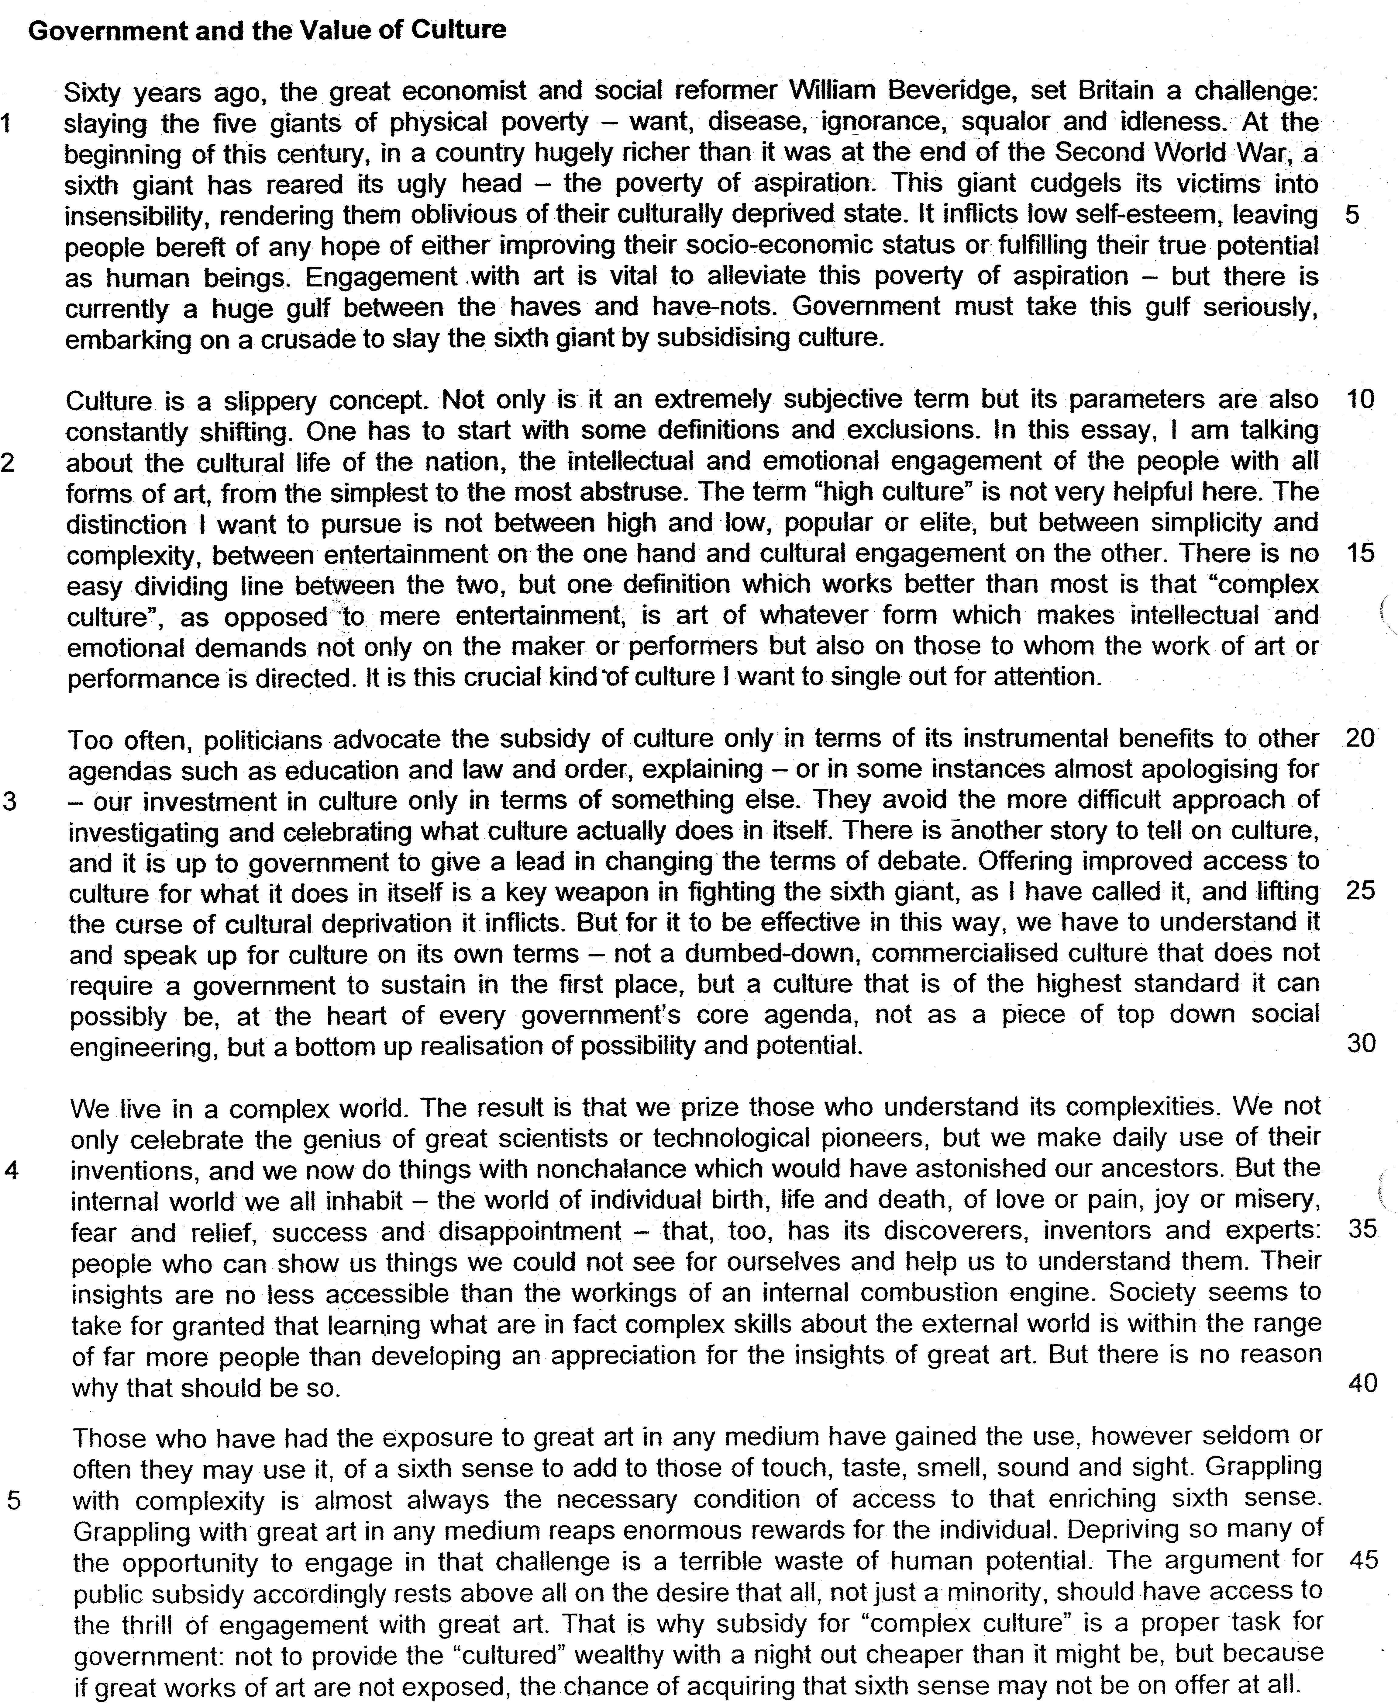

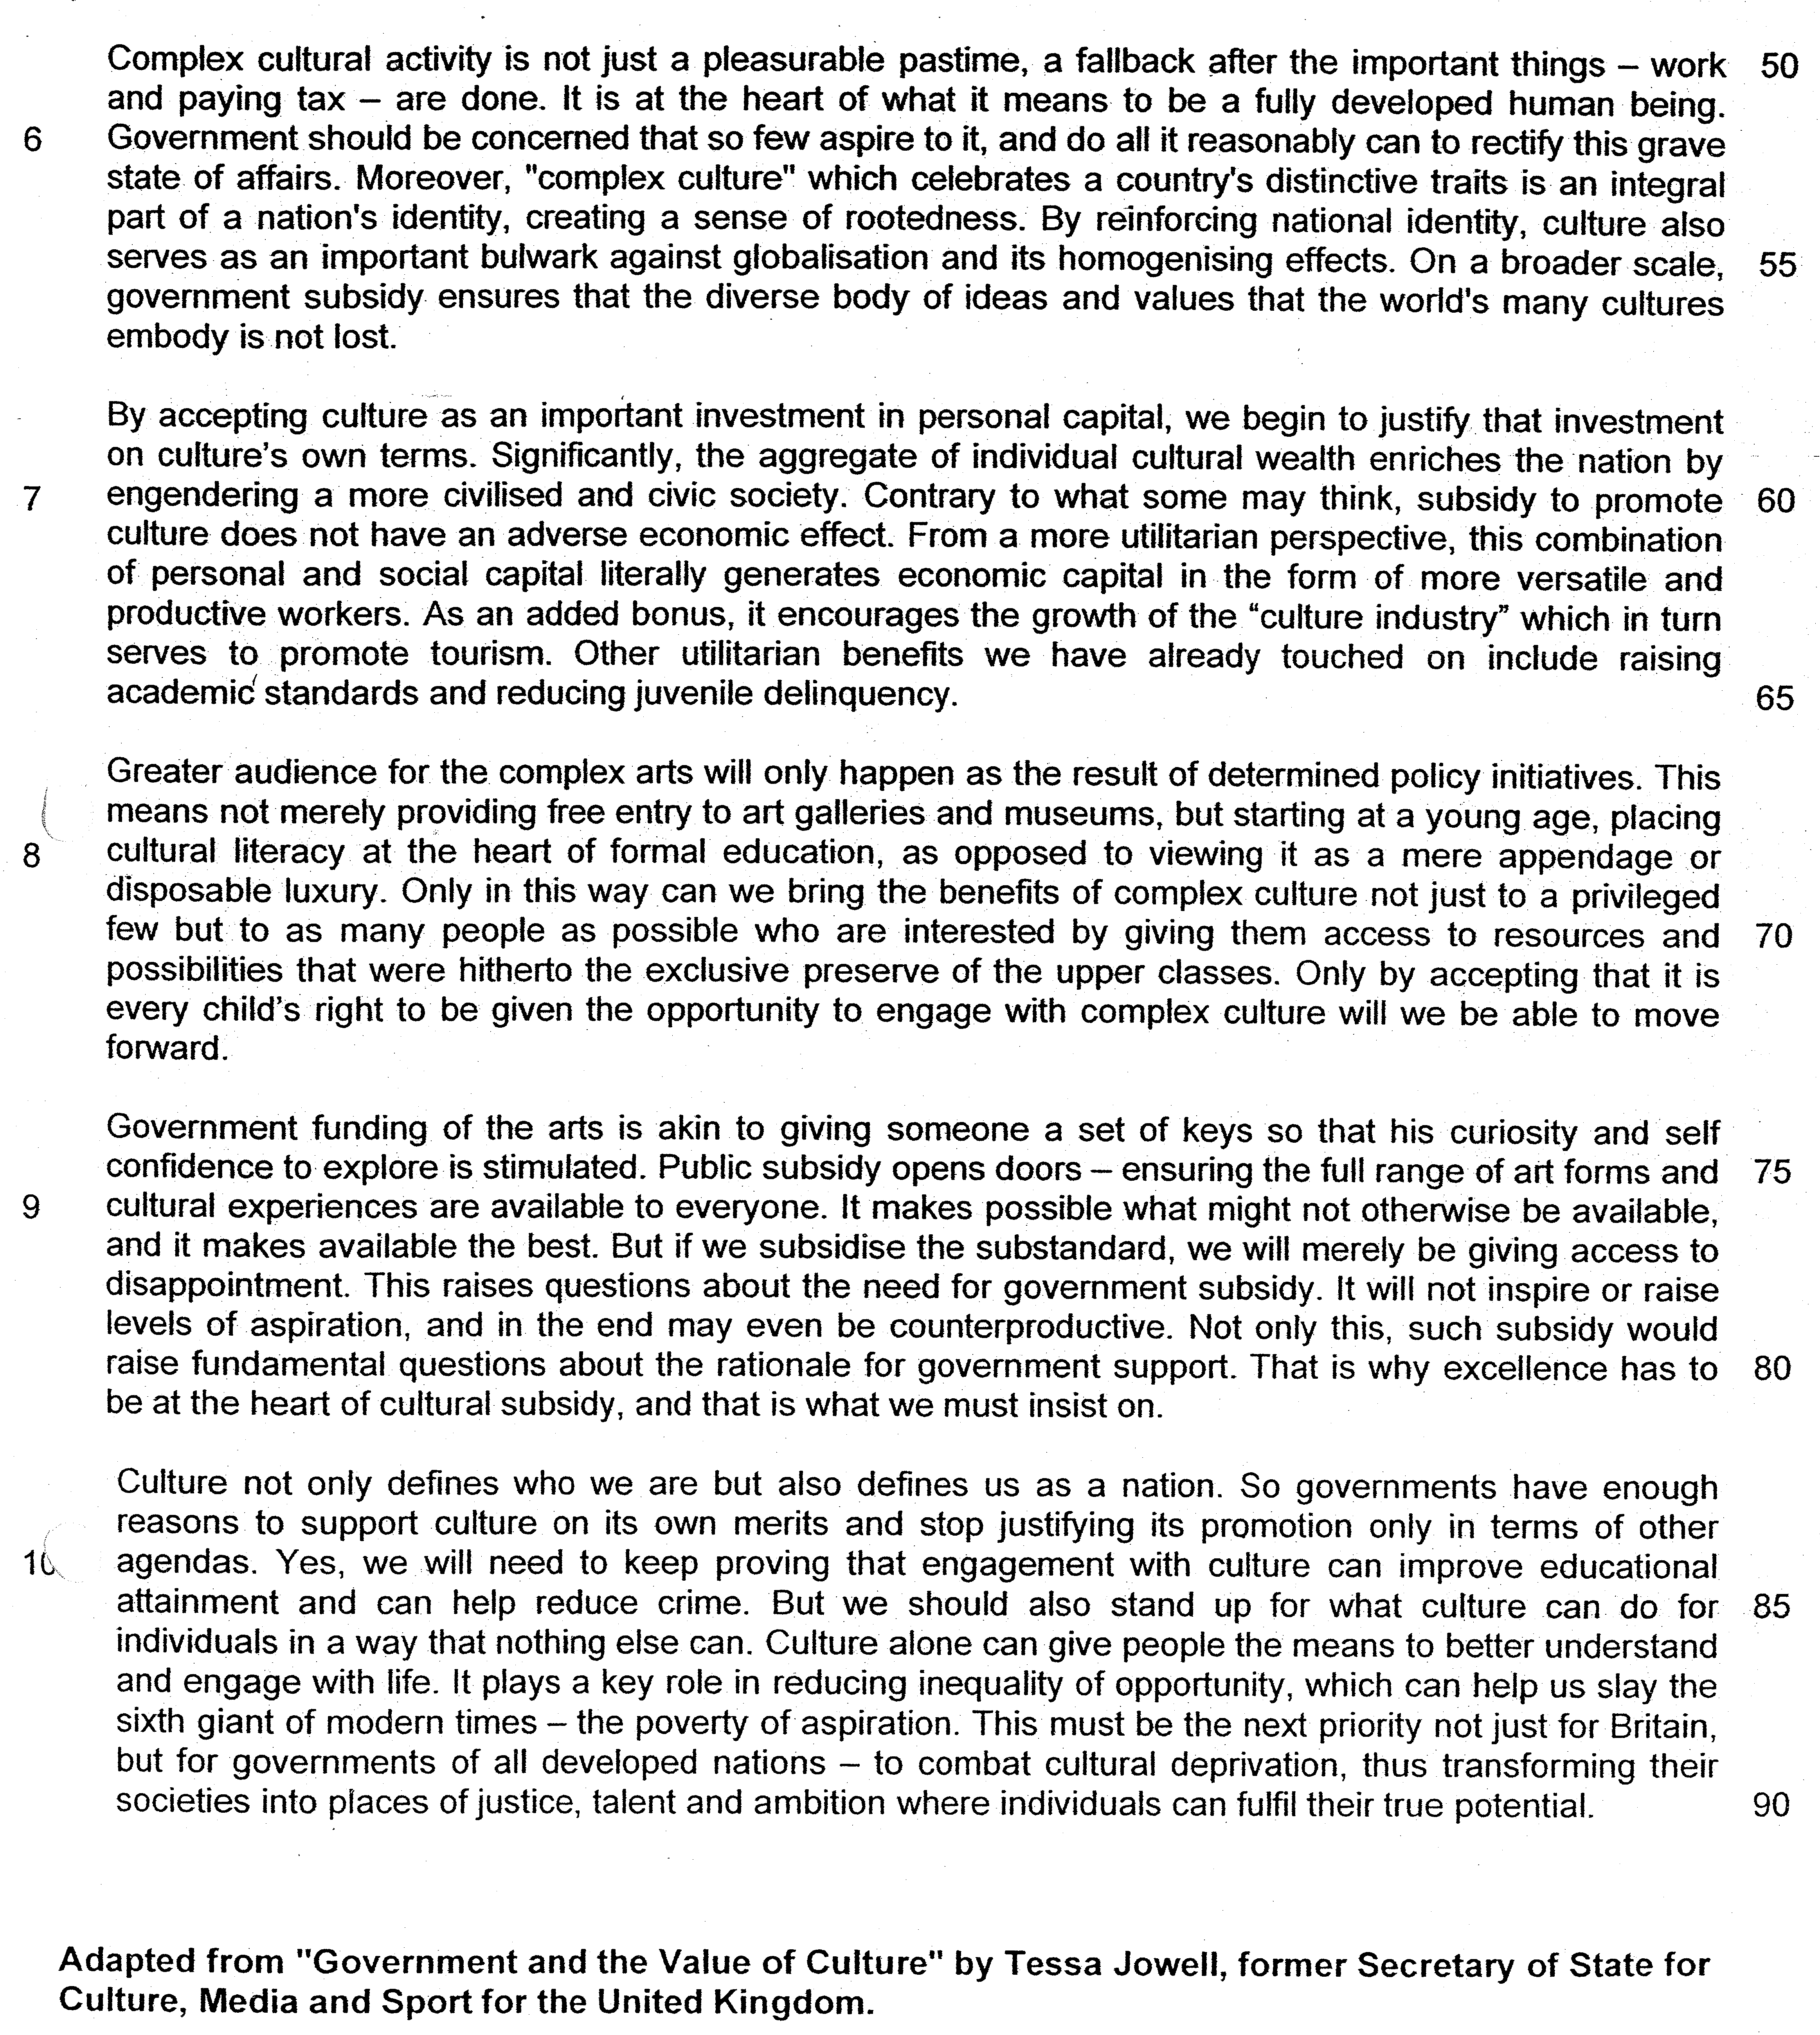

From paragraph 1

1. The writer refers to a "sixth giant" (line 4) in this paragraph. Explain carefully why she wants to "slay" this giant. Answer in your own words as far as possible. [2]

_______________________________________________________________________________________________________________________________________________________________________________________________________________________________________________________________________________________

From paragraph 2

2. Give two reasons why the writer views culture as a "slippery concept" (line 10). Answer in your own words as far as possible. [1]

_______________________________________________________________________________________________________________________________________________________________________________________________________________________________________________________________________________________

3. According to the writer, what is "complex culture" (line 16-17)? Answer in your own words as far as possible. [1]

_______________________________________________________________________________________________________________________________________________________________________________________________________________________________________________________________________________________

From paragraph 3

4. Why do politicians usually "advocate the subsidy of culture only in terms of its instrumental benefits to other agendas" (line 20-21)? Answer in your own words as far as possible. [1]
_______________________________________________________________________________________________________________________________________________________________________________________________________________________________________________________________________________________
5. Why would "commercialised culture" not require government support "in the first place" (lines 27-28)? Answer in your own words as far as possible. [1]

______________________________________________________________________________________________________________________________________________________________________________________________________________________________________________________________________________________

From paragraph 4

6. The writer tells us that "the internal world we all inhabit" has its own "discoverers, inventors and experts" (lines 34-35). Name the specific group of people that she is referring to here. [1]

______________________________________________________________________________________________________________________________________________________________________________________________________________________________________________________________________________________

7. Referring to material from paragraphs 5, 6 and 7, summarise the writer's reasons for arguing that governments should subsidise culture.

Write your summary in no more than 150 words, not counting the opening words which are printed below. Use your own words as far as possible.

The writer argues that governments should subsidise culture because …

______________________________________________________________________________________________________________________________________________________________________________________________________________________________________________________________________________________
_________________________________________________________________________________________________________________________________________________________________________________________
_______________________________________________________________________________________________________________________________________________________________________________________________________________________________________________________________________________________
______________________________________________________________________________________________________________________________________________________________________________________________________________________________________________________________________________________
_______________________________________________________________________________________________________________________________________________________________________________________________________________________________________________________________________________________
__________________________________________________________________________________________________________________________________________________________________________________________
_____________________________________________________________________________________________
_________________________________________________________________________________________[8]

From paragraph 8

8. According to the writer, what is the current role of cultural literacy in education and how does she want to change it? Answer in your own words as far as possible. [2]

______________________________________________________________________________________________________________________________________________________________________________________________________________________________________________________________________________________

9. What does the writer mean when she says the best in art and music were "hitherto the exclusive preserve of the upper classes" (line 71)? Answer in your own words as far as possible. [2]

______________________________________________________________________________________________________________________________________________________________________________________________________________________________________________________________________________________

From paragraph 9

10. Identify and explain the analogy used by the writer in this paragraph. Answer in your own words as far as possible.
[1]

______________________________________________________________________________________________________________________________________________________________________________________________________________________________________________________________________________________

11. Explain why the writer insists that governments should only subsidise cultural excellence. Use your own words as far as possible. [2]

_______________________________________________________________________________________________________________________________________________________________________________________________________________________________________________________________________________________

12. Give the meaning of the following words as they are used in the passage. You may write your answers in one word or a short phrase.

squalor (line 2) __________________________________________________________________________
alleviate (line 7) _________________________________________________________________________
curse (line 26) ___________________________________________________________________________
prize (line 31) ____________________________________________________________________________
accessible (line 37) ___________________________________________________________________[5]

13. The writer contends that it is the duty of governments of all developed nations to extensively subsidise "complex culture".

To what extent do you agree with her arguments?

Discuss the relevance of the issues and ideas raised in this passage to your own country. Refer specifically to relevant material from the passage, as well as your own knowledge and opinions to support your answer.

______________________________________________________________________________________________________________________________________________________________________________________________________________________________________________________________________________________
______________________________________________________________________________________________________________________________________________________________________________________________________________________________________________________________________________________
______________________________________________________________________________________________________________________________________________________________________________________________________________________________________________________________________________________
______________________________________________________________________________________________________________________________________________________________________________________________________________________________________________________________________________________

______________________________________________________________________________________________________________________________________________________________________________________________________________________________________________________________________________________
______________________________________________________________________________________________________________________________________________________________________________________________________________________________________________________________________________________
______________________________________________________________________________________________________________________________________________________________________________________________________________________________________________________________________________________
______________________________________________________________________________________________________________________________________________________________________________________________________________________________________________________________________________________
______________________________________________________________________________________________________________________________________________________________________________________________________________________________________________________________________________________
______________________________________________________________________________________________________________________________________________________________________________________________________________________________________________________________________________________
______________________________________________________________________________________________________________________________________________________________________________________________________________________________________________________________________________________

_________________________________________________________________________________________________________________________________________________________________________________________
______________________________________________________________________________________________________________________________________________________________________________________________________________________________________________________________________________________
______________________________________________________________________________________________________________________________________________________________________________________________________________________________________________________________________________________
______________________________________________________________________________________________________________________________________________________________________________________________________________________________________________________________________________________
______________________________________________________________________________________________________________________________________________________________________________________________________________________________________________________________________________________
______________________________________________________________________________________________________________________________________________________________________________________________________________________________________________________________________________________
______________________________________________________________________________________________________________________________________________________________________________________________________________________________________________________________________________________
_________________________________________________________________________________________[8]

13. The writer contends that it is the duty of governments of all developed nations to extensively subsidise "complex culture".

To what extent do you agree with her arguments?

Discuss the relevance of the issues and ideas raised in this passage to your own country. Refer specifically to relevant material from the passage, as well as your own knowledge and opinions to support your answer.

Thinking aspect:

- Understand the requirements of the question

To derive the extent of agreement to the proposition set by the writer on the issue that it is the duty of all developed nations to extensively subsidize ‘’complex culture”

The nature of discussion is on the extent of agreement to the view of the writer and thus the structure should first depict the writer’s reason for the proposition and why it is agreeable. After this, the evaluation will need to focus on the extent of agreement to this reason proposed by the writer.

In the process to explain why you agree and show the extent of agreement, it is essential that the context of Singapore is applied in the discussion. It is important to show how this reason given by the writer is point that Singapore and the society of Singapore will find it as a reasonable point to accept. Similarly, in the process of the evaluation of the extent of agreement, the grounds for agreement or disagreement must be discussed in the context of Singapore.

- How to make discussion on the extent of agreement for this issue

For this aspect, there are several ways to evaluate the extent of agreement to the reasons provided by the writer:

- Prove why the reason is not right as the implementation based on the reason has negative consequences.
- Prove why the reason may have certain limitations
- Prove why the reason is not acceptable in the context of Singapore

(Please observe how the argument is forged through the structure)

Structure of discussion

1. Quote the point suggested by the writer
2. explain the point
3. why it is agreeable
4. example
5. extent of agreement
6. evaluate the given example or proposed another example
7. linking sentence

- Introduction

State the proposition of the writer and explain the meaning.
List the requirement of the question, stating the nature of discussion. (Extent of agreement)

For example,

To assess the extent of agreement to the writer’s proposition based on the context of Singapore, it is imperative to look at how the subsidy for cultural development in Singapore will affect the society of Singapore and her people.

- Main body

- Quote the phrase from the passage that the writer has used to support his proposition that the government should subsidize complex culture.

The phrase from the passage –

1. One of the reasons that the writer has given to support her view is that ‘complex culture’ is ‘an integral part of national identity, creating a sense of rootedness.’
2. It implies that one of the benefits of complex culture is that it helps to create a sense of belonging that cultivate a common identity.
2. This is agreeable as the cultural development promoted by the society will create an identity for the individual that is linked to the common values and norms of the society. This will link him to a community which the individual can feel a sense of belonging and nurture his identity based on this shared cultural heritage.
4. In Singapore, we are a young nation and this cultural development is critical to the development of a Singapore identity. Over the past years, Singapore has upgraded the building and development of museum like National Museum of Singapore and many other such cultural structures and its government funding has also increased $444.8 million in 2008 to $667.3 million in 2013 as stated by the report of Singapore Cultural Report Statistics 2014 to enrich cultural heritage.

- Identity the reason why this proposition by the writer may or may not be agreeable in the context of Singapore

5. However, such development may not be applicable as the efforts by the government may be seen to be more commercially driven and hindered by our multi-cultural heritage and the influence of a modern society. The values of modern society will draw us away from the common rootedness of heritage culture.
6. Although many have criticized the museum to be too commercially driven for tourism, the number of visits to Museum has increased tremendously as seen from Singapore Culture Statistics 2014. This has made more Singaporeans, especially the youths to understand more about their young nation and forge a sense of belonging. In this way, we have seen the positive development of greater subsidy for cultural development which will nurture a sense of rootedness for a young nation like Singapore.

