\
GP Term 4 2014 – Comprehension – Lesson 1 – Culture – Cultural Heritage

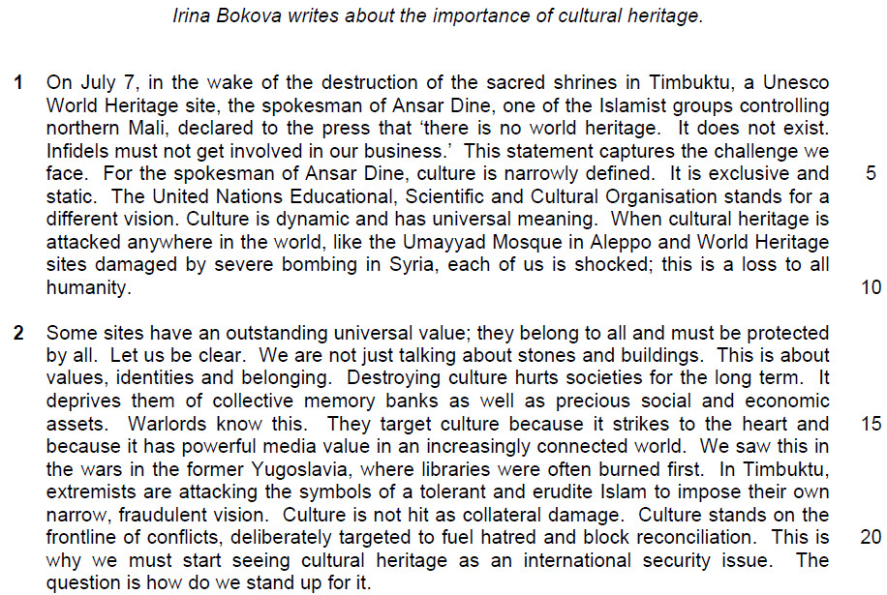

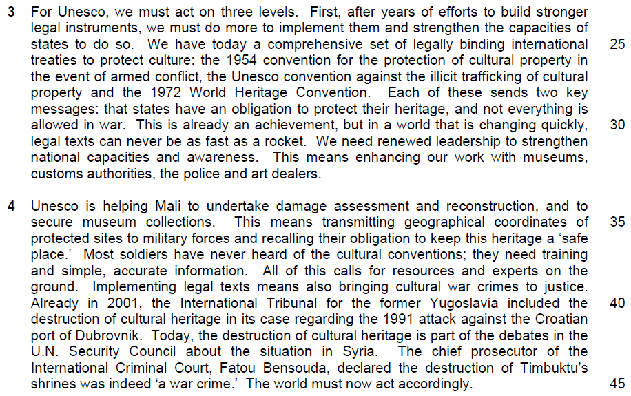

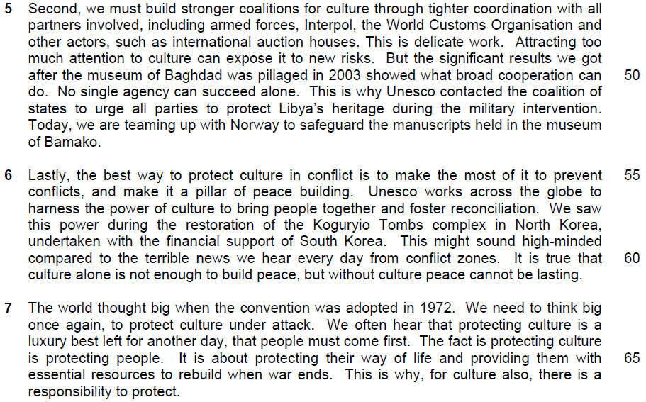

1. What is the author’s purpose in beginning with the quote from the spokesman of Ansar dine (lines 3-4)?

…………………………………………………………………………………………..
…………………………………………………………………………………………..

……………………………………………………………………………………...…..

……………………………………………………………………………………...…..

……………………………………………………………………………………….[1]

2. In paragraph 1, what contrast does the author make between the United Nation’s vision of culture and that of Ansar Dine? Use your own words as far as possible.

…………………………………………………………………………………………..
…………………………………………………………………………………………..

……………………………………………………………………………………...…..

……………………………………………………………………………………...…..

……………………………………………………………………………………….[2]

3. What does that author imply by using the words ‘not just’ to explain the value of cultural sites (line 12)? Use your own words as far as possible.

…………………………………………………………………………………………..
…………………………………………………………………………………………..

……………………………………………………………………………………...…..

……………………………………………………………………………………...…..

……………………………………………………………………………………….[2]

4. Explain what is lost when ‘collective memory banks’ are destroyed (line 14).

…………………………………………………………………………………………..
…………………………………………………………………………………………..

……………………………………………………………………………………...…..

……………………………………………………………………………………...…..

……………………………………………………………………………………….[2]

5. What is the author implying when she says that warlords’ target culture because it strikes to the heart’ (line 15)

…………………………………………………………………………………………..
…………………………………………………………………………………………..

……………………………………………………………………………………...…..

……………………………………………………………………………………...…..

……………………………………………………………………………………….[2]

6. Explain and explain how one example of the author’s use of language in lines 18-19 reflects her overall bias.

…………………………………………………………………………………………..
…………………………………………………………………………………………..

……………………………………………………………………………………...…..

……………………………………………………………………………………...…..

……………………………………………………………………………………….[1]

7. Explain what the author means by saying that targeting culture can ‘fuel hatred and block reconciliation’ (line 20)? Use your own words as far as possible.

…………………………………………………………………………………………..
…………………………………………………………………………………………..

……………………………………………………………………………………...…..

……………………………………………………………………………………...…..

……………………………………………………………………………………….[2]

8. Using material from paragraphs 3-5 only, summarise what the author has to say about what everyone needs to do to protect cultural sites and how to go about doing so.

Write your summary in no more than 120 words, not counting the opening words which are printed below. Use your own words as far as possible.

To protect cultural sites, we must…

…………………………………………………………………………………………..
…………………………………………………………………………………………..

……………………………………………………………………………………...…..

…………………………………………………………………………………………..
…………………………………………………………………………………………..

……………………………………………………………………………………...…..

…………………………………………………………………………………………..
…………………………………………………………………………………………..

……………………………………………………………………………………...…..

…………………………………………………………………………………………..
…………………………………………………………………………………………..

……………………………………………………………………………………...…..

…………………………………………………………………………………………..
…………………………………………………………………………………………..

……………………………………………………………………………………...…..

…………………………………………………………………………………………..
…………………………………………………………………………………………..

…………………………………………………………………………………………..
…………………………………………………………………………………………..

……………………………………………………………………………………...…..

…………………………………………………………………………………………..
…………………………………………………………………………………………..

…………………………………………………………………………………….....[8]

9. In paragraph 6, who might dismiss the author’s argument about the need to protect culture in conflict?

…………………………………………………………………………………………..
…………………………………………………………………………………………..

……………………………………………………………………………………...…..

……………………………………………………………………………………...…..

……………………………………………………………………………………….[1]

10. In paragraph 7, what does the author suggest would be lost if we fail to protect culture? Use your own words as far as possible.

…………………………………………………………………………………………..
…………………………………………………………………………………………..

……………………………………………………………………………………...…..

……………………………………………………………………………………...…..

……………………………………………………………………………………….[2]

11. Why does the author keep repeating the words ‘protect’ and ‘protecting’ in the last paragraph?

…………………………………………………………………………………………..
…………………………………………………………………………………………..

……………………………………………………………………………………...…..

……………………………………………………………………………………...…..

……………………………………………………………………………………….[2]

11. Irina Bokva feels that cultural heritage belongs to all and must be protected by all. To what extent do you agree or disagree with her views? How applicable do you find her observations to yourself and your own society?

…………………………………………………………………………………………..
…………………………………………………………………………………………..
…………………………………………………………………………………………..
…………………………………………………………………………………………..
…………………………………………………………………………………………..
…………………………………………………………………………………………..
…………………………………………………………………………………………..
…………………………………………………………………………………………..
…………………………………………………………………………………………..
…………………………………………………………………………………………..
…………………………………………………………………………………………..
…………………………………………………………………………………………..
…………………………………………………………………………………………..
…………………………………………………………………………………………..
…………………………………………………………………………………………..
…………………………………………………………………………………………..
…………………………………………………………………………………………..
…………………………………………………………………………………………..
…………………………………………………………………………………………..
…………………………………………………………………………………………..

…………………………………………………………………………………………..
…………………………………………………………………………………………..
…………………………………………………………………………………………..
…………………………………………………………………………………………..
…………………………………………………………………………………………..
…………………………………………………………………………………………..
…………………………………………………………………………………………..
…………………………………………………………………………………………..
…………………………………………………………………………………………..
…………………………………………………………………………………………..
…………………………………………………………………………………………..
…………………………………………………………………………………………..
…………………………………………………………………………………………..
…………………………………………………………………………………………..
…………………………………………………………………………………………..
…………………………………………………………………………………………..
…………………………………………………………………………………………..
…………………………………………………………………………………………..
…………………………………………………………………………………………..
…………………………………………………………………………………………..
…………………………………………………………………………………………..
…………………………………………………………………………………………..
…………………………………………………………………………………………..
…………………………………………………………………………………………..

…………………………………………………………………………………………..
…………………………………………………………………………………………..
…………………………………………………………………………………………..
…………………………………………………………………………………………..
…………………………………………………………………………………………..
…………………………………………………………………………………………..
…………………………………………………………………………………………..
…………………………………………………………………………………………..
…………………………………………………………………………………………..
…………………………………………………………………………………………..
…………………………………………………………………………………………..
…………………………………………………………………………………………..
…………………………………………………………………………………………..
…………………………………………………………………………………………..
…………………………………………………………………………………………..
…………………………………………………………………………………………..
…………………………………………………………………………………………..
…………………………………………………………………………………………..
…………………………………………………………………………………………..
…………………………………………………………………………………………..
…………………………………………………………………………………………..
…………………………………………………………………………………….[8]

