GP Term 4 2017 – Comprehension Topic 3: Personal Issues – Materialism (Tutor)

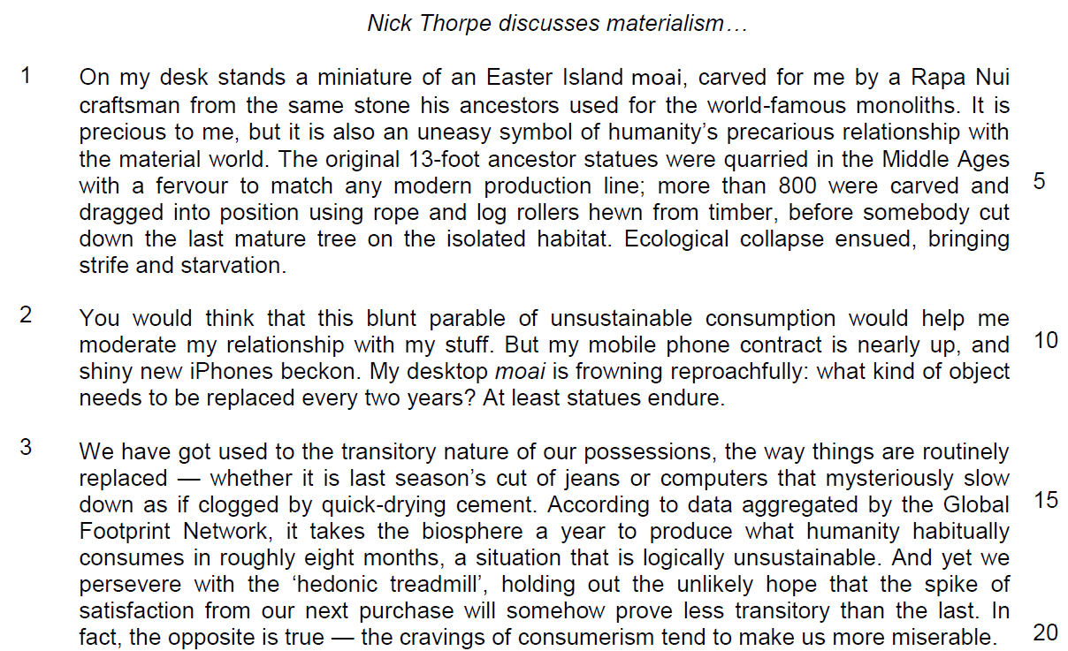

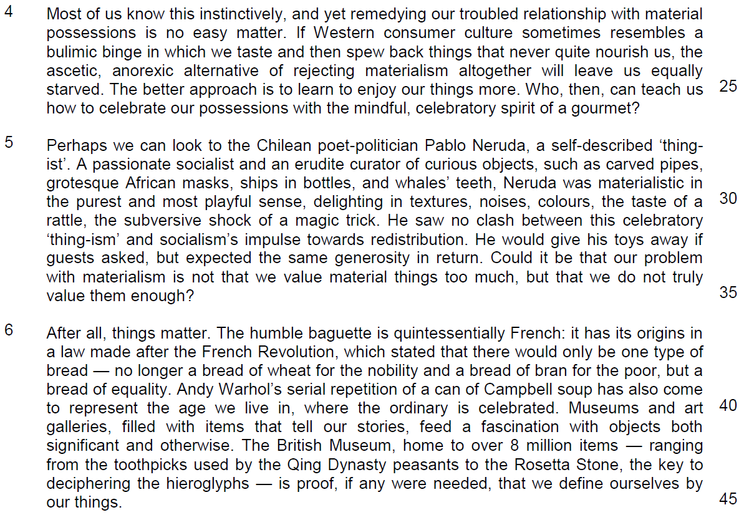

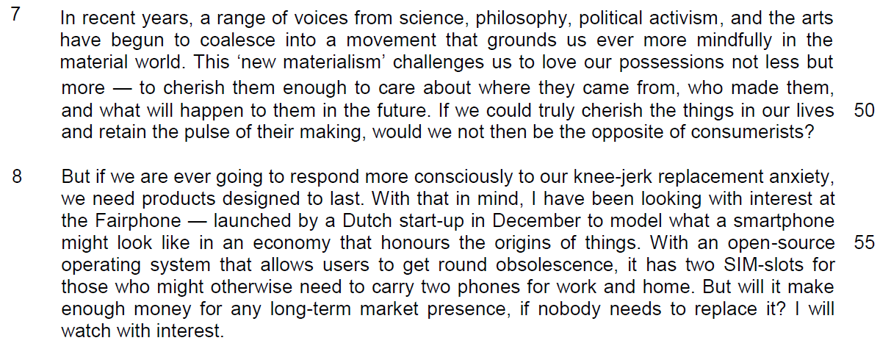

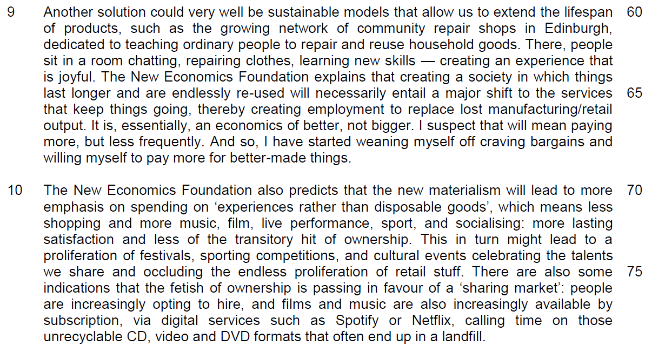

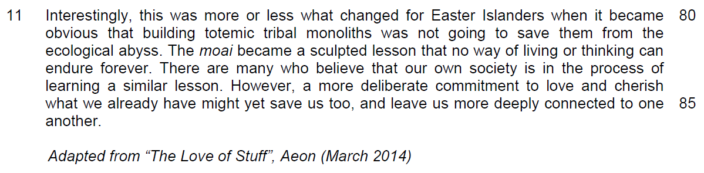

Suggested Answers
1. Using your own words as far as possible, explain what the author means when he describes his miniature moai as an ‘uneasy symbol’ (line 3). [2]

From Passage
It is precious to me, but it is also an uneasy… symbol of…

Ecological collapse ensued, bring strife and starvation… uneasy symbol of humanity’s precarious relationship with the material world.

Inferred Answer
The author means that it is a troubling representation of the devastation mankind unleashed on the environment because of our materialism/ consumption patterns.

2. Suggest one reason why the author might perceive his desktop moai as ‘frowning reproachfully’ in line 11. [1]

From Passage
My desktop moai frowns reproachfully: what kind of object needs to be replaced every two years? At least statues endure.

Inferred Answer
The author’s purpose is to convey his guilty conscience regarding wanting to replace his mobile phone.

OR
The author feels bad about wanting to replace his mobile phone.

3. What does the word ‘routinely’ (line 13) suggest about the way we replace our possessions? [1]

From Passage
We have got used to the transitory nature of our possessions, the way things are routinely replaced…

Inferred Answer
The author is suggesting that we replace our possessions in a mindless/ unthinking/ careless way.

4. What can you infer from the examples in lines 14 and 15 about the reasons why our possessions are replaced? [2]

From Passage
whether it is last season’s cut of jeans…or computers that mysteriously slow down as if clogged by quick-drying cement

Inferred Answer
We replace our possessions because the items are no longer trendy, or because there is some built-in obsolescence in the product/ the manufacturers made the product so that it will need to be replaced after a short amount of time.

5. In lines 17 to 20, what is the contrast the author makes between what we hope our products can do for us and what he believes to be the reality? Use your own words as far as possible. [2]

From Passage
…holding out the unlikely hope that the spike of satisfaction from our next purchase will somehow prove less transitory than the last.

In fact, the opposite is true— the cravings of consumerism tend to make us more miserable.

Inferred Answer
We hope that the fulfilment we get from our products will last for a long time.

OR
We hope that we will ultimately be fulfilled by our purchases.

6. What does the author mean when he uses the phrase ‘equally starved’ (lines 24 - 25)? Use your own words as far as possible. [2]

From Passage
If Western consumer culture sometimes resembles a bulimic binge in which we taste and then spew back things that never quite nourish us, the ascetic, anorexic alternative of rejecting materialism altogether will leave us equally starved.

Answer
The author means that whether we embrace consumerism or if we give up on buying things completely, we will not be satisfied/ fulfilled.

7. In paragraph 5, identify a word or phrase that shows how Pablo Neruda exemplifies a (i) ‘mindful’ and (ii) ‘celebratory’ spirit (line 26). [2]

(i) mindful

Answer
An erudite curator of curious objects.

(ii) celebratory

Answer
delighting in textures, noises, colours, et cetera.

OR
materialistic in the purest and most playful sense.

8. In paragraph 6, what similarities does the author draw between the baguette and the can of Campbell soup? Use your own words as far as possible. [2]

From Passage
the humble baguette… A can of Campbell soup…. where the ordinary are celebrated.

The humble baguette is quintessentially French: it has his origins in a law made after the French Revolution… A can of Campbell soup has also come to represent the age we live in…

Inferred Answer
Both the can of Campbell soup and the baguette are mundane/ insignificant/ common items, and are symbols of/ tell us about an important aspect of our culture/ era/ values/ who we are/ what society is.

Summary Question
9. Using material from paragraphs 7 to 10 only (lines 46 to 79), summarise what the author says about how we can counter materialism and the effects of these actions.

Write your summary in no more than 120 words, not counting the opening words which are printed below. Use your own words as far as possible. [8]

We can counter materialism by…

# | From text | Paraphrased/ Inference
A | a range of voices from science, philosophy, political activism and the arts have begun to coalesce into a movement that… | …coming together/ working collectively
B | grounds us ever more mindfully in the material world | .... towards being more thoughtfully/ deliberately/ consciously/  centred/ rooted/ established  in the physical/ corporeal/ tangible world.
C | …challenges us to love our possessions not less but more — to cherish them enough… | We can value our things,
D | …to care about where they came from,  Or  honours the origins of things | be concerned about their source,
E | who made them, | their manufacturers,
F | what will happen to them in the future. | and what will become of them  OR  how they will be disposed/ recycled/ reused,
G | …retain the pulse of their making | and in so doing, remember the essence of how they were made.
H | we need products that last.  OR  a society in which things last longer | We need to make things that endure
I | with an open-source operating system that allow users to get round obsolescence, | and provide ways to keep products up-to-date/ useful/ relevant.
J | it has two SIM-slots for those who might otherwise need to carry two phones for work and home | Businesses also need to streamline their products/ make products that are multi-functional
K | sustainable models of extending the lifespan of products such as the growing network of community repair shops | We can fix our things when they break down,

# | From text | Paraphrased/ Inference
L | …entail a major shift to the services that keep things going, thereby creating employment… | [effect] and this creates new jobs in industries that restore/mend/fix items
M | …to replace lost manufacturing/retail output. | [effect] and leads to fewer jobs in the production/service industry
N | …and are endlessly re-used | We can constantly/continually  upcycle/ re-purpose/ recycling.
O | It is, essentially, an economics of better, not bigger. | We need to focus on manufacturing/buying products of higher quality.
P | I suspect that will mean paying more, OR  I’ve started weaning myself off craving bargains | We have to be willing to spend more.
Effects
Q | spending on ‘experiences rather than disposable goods’ | We will pursue adventure/ memorable activities,
R | more lasting satisfaction | and this will lead to more fulfilment
S | more lasting satisfaction  OR  and less of the transitory hit of ownership | that endures/ is long-term/ more permanent.
T | This in turn might lead to a proliferation of festivals, sporting competitions and cultural events celebrating the talents we share. | This will lead to more activities that commemorate/ recognise/ focus on the gifts/abilities/skills we have.
U | There are some indications that the fetish of ownership | We will be less keen to possess,
V | is passing in favour of a ‘sharing market’  OR hire OR by subscription | and more keen to share/ rent/ pay for streaming
W | Calling time on those unrecyclable CD, video and DVD formats that often end up in a landfill. | There will be less waste.

10. According to the author in lines 82 to 86, what are the lessons that we can learn from the moai? Use your own words as far as possible. [3]

From Passage
The moai became a sculpted lesson that no way of living or thinking can endure forever…a more deliberate…commitment to love and cherish what we already have might yet save us

Inferred Answer
We learn that we must change, we need to be more conscious/ thoughtful/ purposeful/ mindful and dedicated in caring for what we have.

Application Question (AQ)
11. In this article, Nick Thorpe writes about the problems of materialism and how individuals and companies can counter it. How relevant are his arguments to you and your society? [10]

Analysis of the question:

problems of materialism and solutions

- unwillingness to repair and reuse – solutions? – seen in your society
- relevance – why it is relevant to your society?
    - why it is not relevant to your society?
    - is the problem and solution relevant to you?
(example is based on an incident you have experienced or in your social background)
Introduction
description – how problems of materialism are affecting us and what are the solutions proposed
the requirements – are these relevant to us

main body

Quote: unwillingness to reuse - expand the life-span of products through the setup of repair shops

explain: usable and less buying – reduce materials through reuse

why it is relevant to your society: very few people can have the art and crafts to do repair, non-sustainable, mindset of the consumers – anything that is broken is considered unworkable.

inconvenient, not easy to transport, troublesome – have a lot to consume – more costly to repair than buy a new item

Example: guarantee for products are for a short period as producers are not ready to encourage repair – proportion of income spent on the good is lesser, very few repair shops in Singapore
It products – simply replaced you with a new item for default – cost of repairing is higher than cost of manufacturing

