GP Comprehension – Importance of Tradition

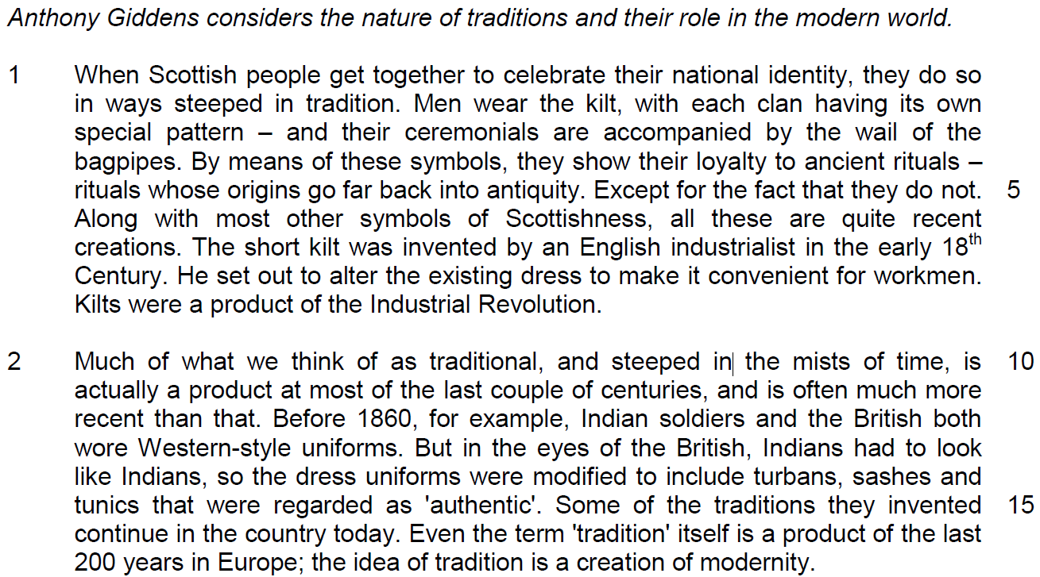

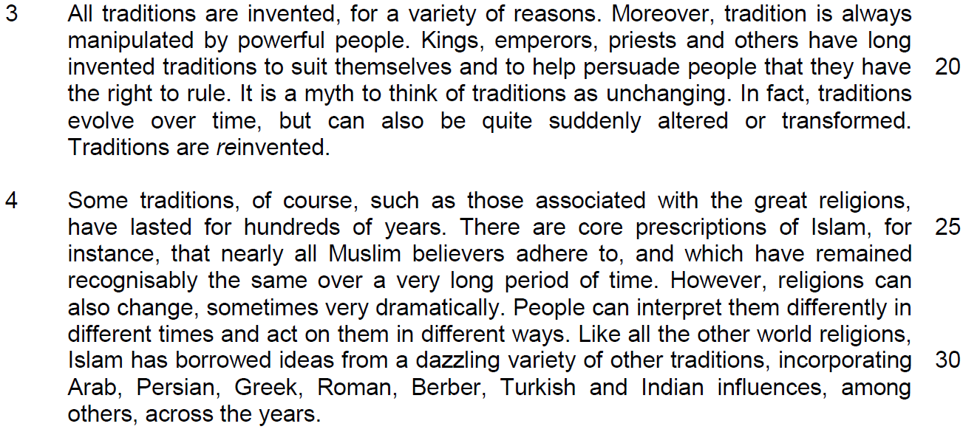

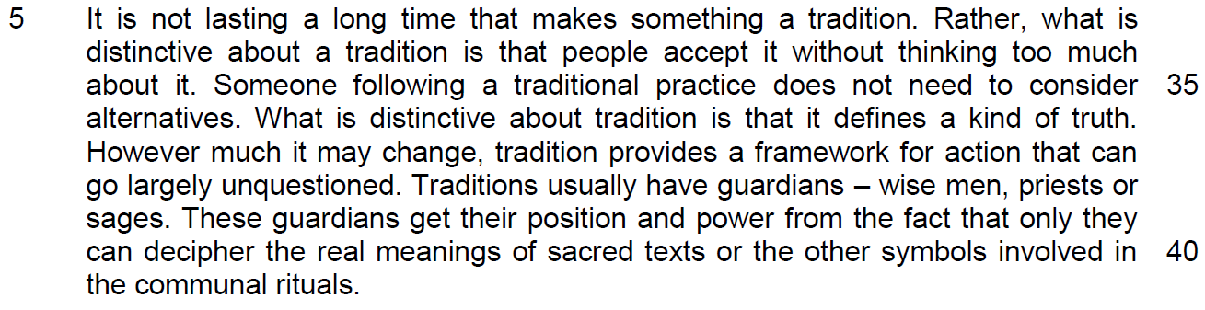
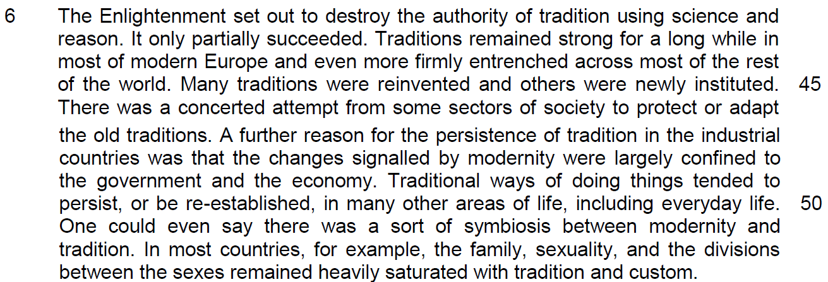

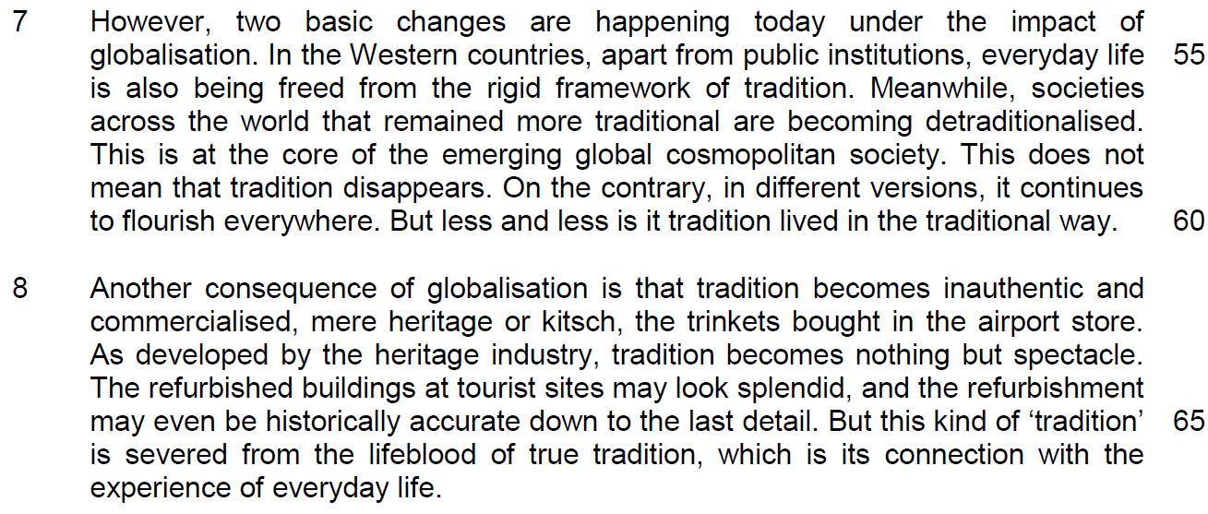

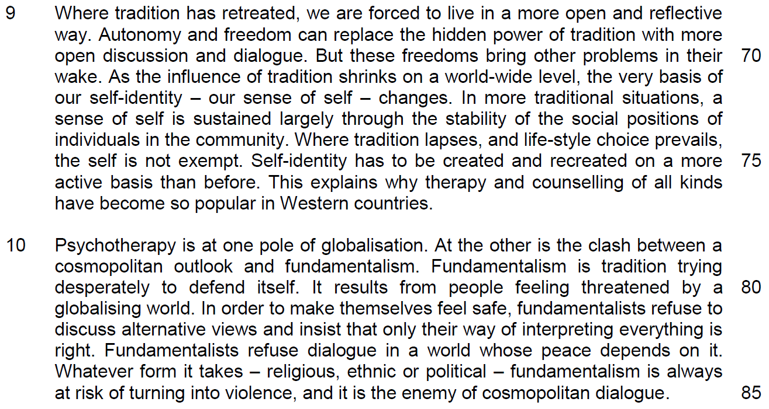
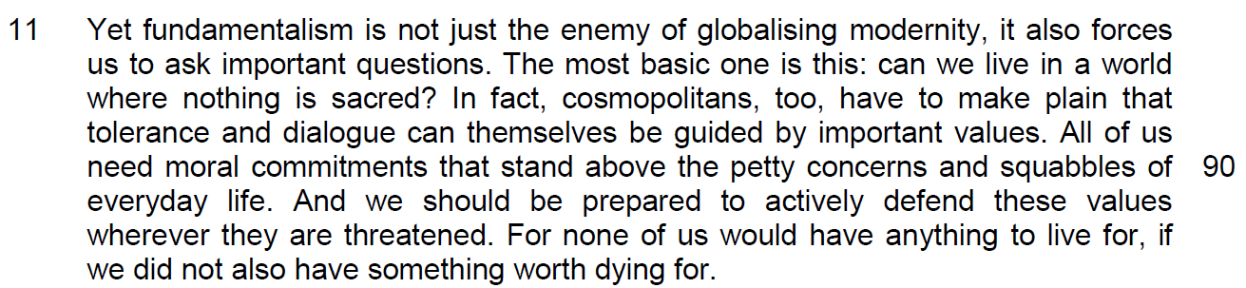

Read the passage in the insert and then answer all the questions which follow. Note that up to fifteen marks will be given for the quality and accuracy of your use of English throughout this Paper.

NOTE: When a question asks for an answer IN YOUR OWN WORDS AS FAR AS POSSIBLE and you select the appropriate material from the passage for your answer, you must use your own words to express it. Little credit can be given to answers which only copy words or phrases from the passage.

Q1) ‘Except for the fact that they do not.’ (line 5) What does this sentence indicate about the perception of rituals described in lines 1 – 5? [1]

……………………………………………………………………………………………………………………………………

……………………………………………………………………………………………………………………………………

Q2) Why is the word ‘authentic’ (line 15) in inverted commas? [2]

……………………………………………………………………………………………………………………………………
……………………………………………………………………………………………………………………………………

……………………………………………………………………………………………………………………………………

Q3) Why is it paradoxical that ‘the idea of tradition is a creation of modernity’ (line 17)? [2]

……………………………………………………………………………………………………………………………………
……………………………………………………………………………………………………………………………………

……………………………………………………………………………………………………………………………………

Q4) In the third paragraph, how does the author illustrate the idea that ‘tradition is always manipulated by powerful people’ (lines 18 – 19)? Use your own words as far as possible. [2]

……………………………………………………………………………………………………………………………………
……………………………………………………………………………………………………………………………………

……………………………………………………………………………………………………………………………………

Q5) Why is the prefix ‘re’ in italics in the word ‘reinvented’ (line 23)? [2]

……………………………………………………………………………………………………………………………………
……………………………………………………………………………………………………………………………………

……………………………………………………………………………………………………………………………………

Q6) What is the author implying about the core prescriptions of Islam by his use of the word ‘recognisably’ (line 27)? [1]

……………………………………………………………………………………………………………………………………
……………………………………………………………………………………………………………………………………

Q7) Why are ‘therapy and counselling of all kinds’ (lines 76) becoming popular in Western countries? Use your own words as far as possible. [3]

……………………………………………………………………………………………………………………………………
……………………………………………………………………………………………………………………………………

……………………………………………………………………………………………………………………………………

……………………………………………………………………………………………………………………………………

Q8) In paragraph 10, what are two differences between a cosmopolitan outlook and fundamentalism? Use your own words as far as possible. [2]

(a)………………………………………………………………………………………………………………………………
……………………………………………………………………………………………………………………………………

(b)………………………………………………………………………………………………………………………………

……………………………………………………………………………………………………………………………………

Q9) From paragraph 11, identify two phrases or sentences in which the author seeks to engage his audience, and in each case, explain how the author’s language seeks to achieve this effect. [2]

(a)…………………………………………………….…………………………………………………………………………
……………………………………………………………………………………………………………………………………

(b).………………………………………………………………………………………………………………………………

……………………………………………………………………………………………………………………………………

Summary Writing
Q12) Using material from paragraphs 5 – 8 only, summarise what the author has to say about the defining features of tradition, the reasons why traditions remained strong in modern society and the impact of globalisation on traditions.

Write your summary in no more than 120 words, not counting the opening words which are printed below. Use your own words as far as possible.

One defining feature of tradition is …
S/No | From the passage | Paraphrased equivalent
1 | people accept it without thinking too much about it / largely unquestioned
2 | What is distinctive about tradition is that it defines a kind of truth
3 | tradition provides a framework for action
4 | Traditions usually have guardians
5 | Many traditions were reinvented
6 | others were newly instituted
7 | There was a concerted attempt from some sectors of society
8 | to protect
9 | or adapt the old traditions
10 | Changes signaled by modernity were largely confined to the government.
11 | and the economy

S/No | Points/Ideas from the passage (Essence of the point/idea in bold) | Paraphrased equivalent
12 | Traditional ways of doing things tended to persist, or be re-established, in many other areas of life, including everyday life.
13 | there was a sort of symbiosis between modernity and tradition.
14 | the family, sexuality, and the divisions between the sexes remained heavily saturated with tradition and custom.
15 | In the Western countries, not just public institutions
16 | but everyday life
17 | being freed from the rigid framework of tradition
18 | Societies across the world that remained more traditional are becoming detraditionalised.
19 | in different versions
20 | It continues to flourish everywhere.
21 | But less and less is it tradition lived in the traditional way.
22 | tradition becomes inauthentic
23 | Commercialized, mere heritage or kitsch
24 | tradition becomes nothing but spectacle
25 | But this kind of ‘tradition’ is severed from …connection with the experience of everyday life

Application Question
Q13) In this article, Giddens discusses the changing nature of tradition and its importance in society. How applicable do you find his observations to yourself and your society? [10]
……………………………………………………………………………………………………………………………………
……………………………………………………………………………………………………………………………………

……………………………………………………………………………………………………………………………………
……………………………………………………………………………………………………………………………………

……………………………………………………………………………………………………………………………………
……………………………………………………………………………………………………………………………………

……………………………………………………………………………………………………………………………………
……………………………………………………………………………………………………………………………………

……………………………………………………………………………………………………………………………………
……………………………………………………………………………………………………………………………………

……………………………………………………………………………………………………………………………………
……………………………………………………………………………………………………………………………………

……………………………………………………………………………………………………………………………………
……………………………………………………………………………………………………………………………………

……………………………………………………………………………………………………………………………………
……………………………………………………………………………………………………………………………………

……………………………………………………………………………………………………………………………………
……………………………………………………………………………………………………………………………………

……………………………………………………………………………………………………………………………………
……………………………………………………………………………………………………………………………………

……………………………………………………………………………………………………………………………………
……………………………………………………………………………………………………………………………………

……………………………………………………………………………………………………………………………………
……………………………………………………………………………………………………………………………………
……………………………………………………………………………………………………………………………………

……………………………………………………………………………………………………………………………………
……………………………………………………………………………………………………………………………………

……………………………………………………………………………………………………………………………………
……………………………………………………………………………………………………………………………………

……………………………………………………………………………………………………………………………………
……………………………………………………………………………………………………………………………………

……………………………………………………………………………………………………………………………………
……………………………………………………………………………………………………………………………………

……………………………………………………………………………………………………………………………………
……………………………………………………………………………………………………………………………………

……………………………………………………………………………………………………………………………………
……………………………………………………………………………………………………………………………………

……………………………………………………………………………………………………………………………………
……………………………………………………………………………………………………………………………………

……………………………………………………………………………………………………………………………………
……………………………………………………………………………………………………………………………………

……………………………………………………………………………………………………………………………………
……………………………………………………………………………………………………………………………………

……………………………………………………………………………………………………………………………………
……………………………………………………………………………………………………………………………………

