GP Term 4 2017 – Comprehension Topic 3: Personal Issues – Materialism

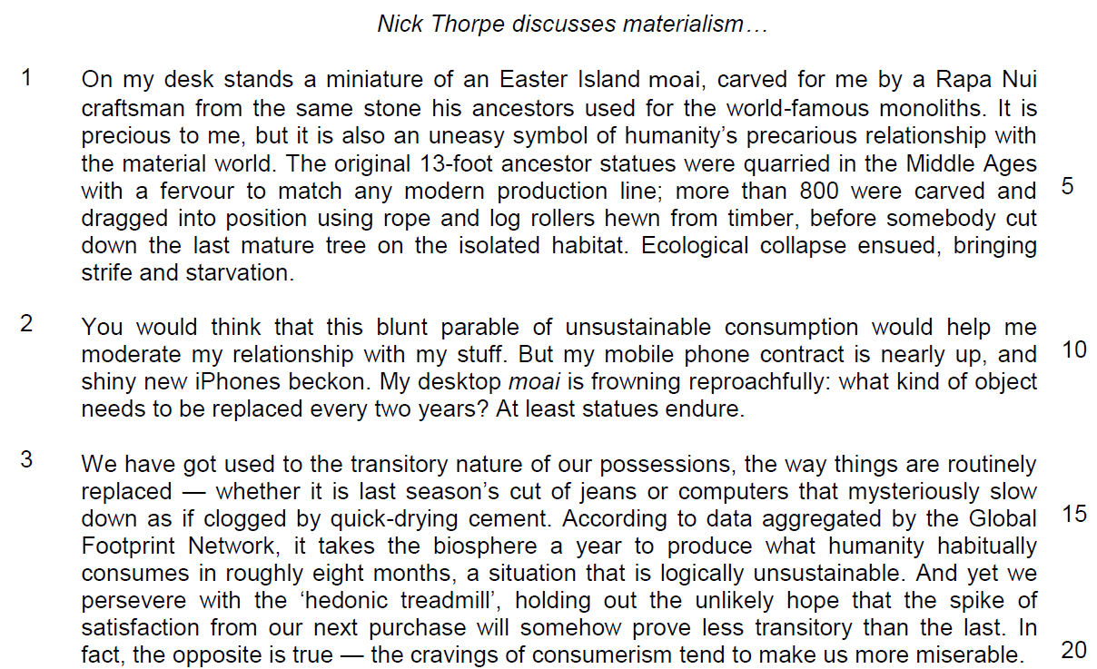

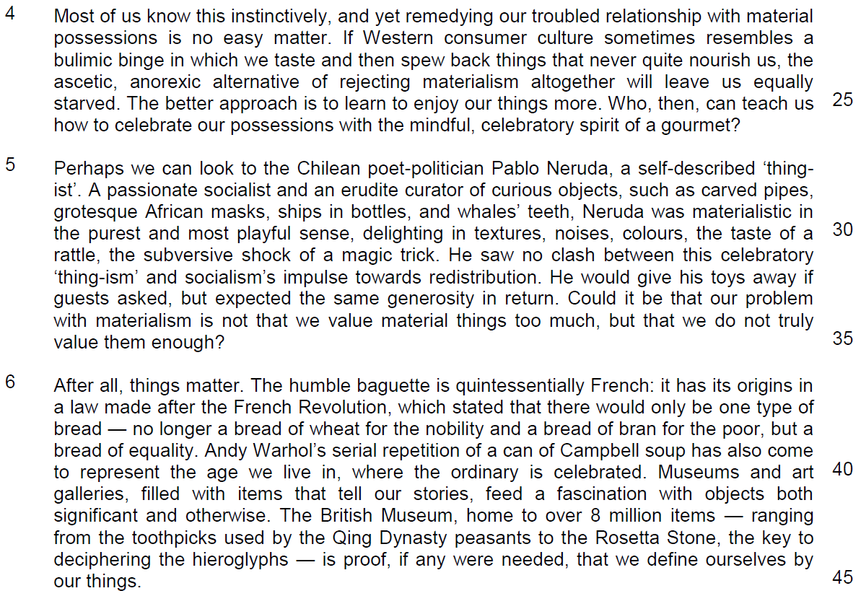

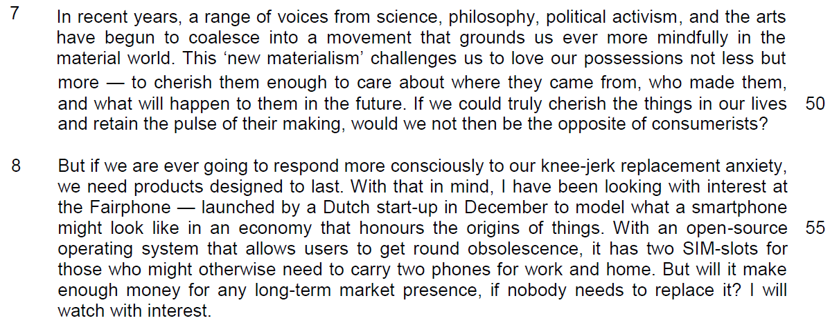

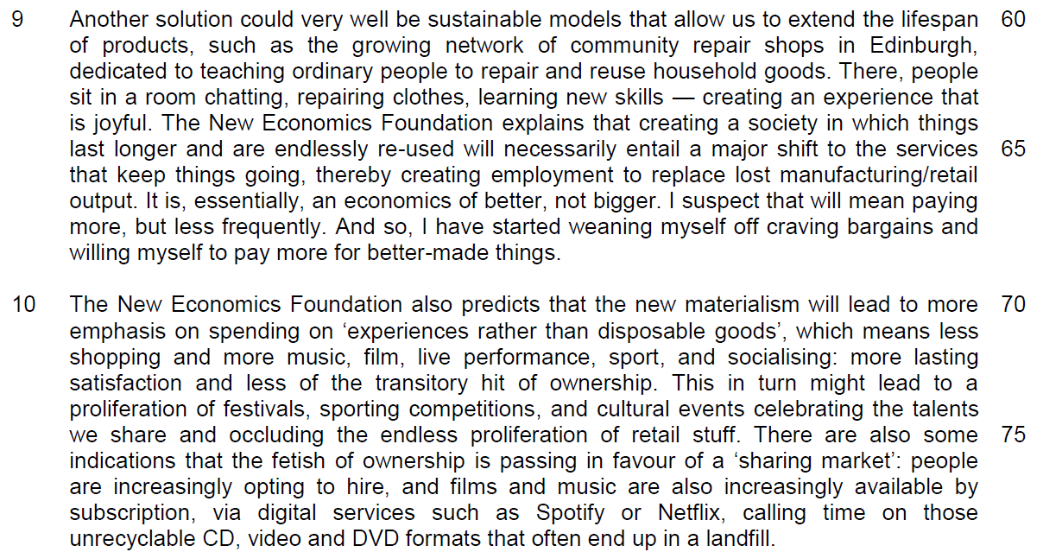

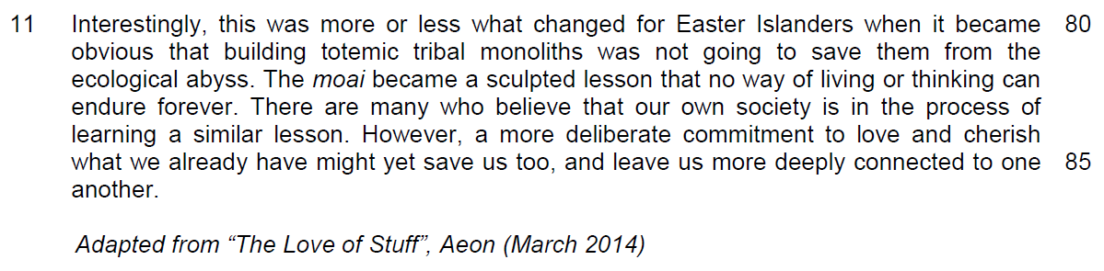

Read the passages in the insert and then answer all the questions which follow below. Note that up to fifteen marks will be given for the quality and accuracy of your use of English throughout this Paper.

NOTE: When a question asks for an answer IN YOUR OWN WORDS AS FAR AS POSSIBLE and you select the appropriate material from the passage for your answer, you must still use your own words to express it. Little credit can be given to answers which only copy words or phrases from the passage.

Questions
1. Using your own words as far as possible, explain what the author means when he describes his miniature moai as an ‘uneasy symbol’ (line 3). [2]

…………………………………………………………………………………………..

…………………………………………………………………………………………..
…………………………………………………………………………………………..

…………………………………………………………………………………………..

2. Suggest one reason why the author might perceive his desktop moai as ‘frowning reproachfully’ in line 11. [1]

…………………………………………………………………………………………..

…………………………………………………………………………………………..

3. What does the word ‘routinely’ (line 13) suggest about the way we replace our possessions? [1]

…………………………………………………………………………………………..

…………………………………………………………………………………………..

4. What can you infer from the examples in lines 14 and 15 about the reasons why our possessions are replaced? [2]

…………………………………………………………………………………………..

…………………………………………………………………………………………..

…………………………………………………………………………………………..

…………………………………………………………………………………………..

5. In lines 17 to 20, what is the contrast the author makes between what we hope our products can do for us and what he believes to be the reality? Use your own words as far as possible. [2]

…………………………………………………………………………………………..

…………………………………………………………………………………………..

…………………………………………………………………………………………..

…………………………………………………………………………………………..

6. What does the author mean when he uses the phrase ‘equally starved’ (lines 24 - 25)? Use your own words as far as possible. [2]

…………………………………………………………………………………………..

…………………………………………………………………………………………..

…………………………………………………………………………………………..

…………………………………………………………………………………………..

7. In paragraph 5, identify a word or phrase that shows how Pablo Neruda exemplifies a (i) ‘mindful’ and (ii) ‘celebratory’ spirit (line 26). [2]

(i) mindful:

…………………………………………………………………………………………..

(ii) celebratory:

…………………………………………………………………………………………..

8. In paragraph 6, what similarities does the author draw between the baguette and the can of Campbell soup? Use your own words as far as possible. [2]

…………………………………………………………………………………………..

…………………………………………………………………………………………..

…………………………………………………………………………………………..

…………………………………………………………………………………………..

Summary Question
9. Using material from paragraphs 7 to 10 only (lines 46 to 79), summarise what the author says about how we can counter materialism and the effects of these actions.

Write your summary in no more than 120 words, not counting the opening words which are printed below. Use your own words as far as possible. [8]

We can counter materialism by ……………………………………………………...

…………………………………………………………………………………………..

…………………………………………………………………………………………..

…………………………………………………………………………………………..

…………………………………………………………………………………………..

…………………………………………………………………………………………..

…………………………………………………………………………………………..

…………………………………………………………………………………………..

…………………………………………………………………………………………..

…………………………………………………………………………………………..

…………………………………………………………………………………………..

…………………………………………………………………………………………..

…………………………………………………………………………………………..

…………………………………………………………………………………………..

…………………………………………………………………………………………..

…………………………………………………………………………………………..

…………………………………………………………………………………………..

…………………………………………………………………………………………..

…………………………………………………………………………………………..

10. According to the author in lines 82 to 86, what are the lessons that we can learn from the moai? Use your own words as far as possible. [3]

…………………………………………………………………………………………..

…………………………………………………………………………………………..

…………………………………………………………………………………………..

…………………………………………………………………………………………..

…………………………………………………………………………………………..

…………………………………………………………………………………………..

Application Question (AQ)
11. In this article, Nick Thorpe writes about the problems of materialism and how individuals and companies can counter it. How relevant are his arguments to you and your society? [10]

…………………………………………………………………………………………..

…………………………………………………………………………………………..

…………………………………………………………………………………………..

…………………………………………………………………………………………..

…………………………………………………………………………………………..

…………………………………………………………………………………………..

…………………………………………………………………………………………..

…………………………………………………………………………………………..

…………………………………………………………………………………………..

…………………………………………………………………………………………..

…………………………………………………………………………………………..

…………………………………………………………………………………………..

…………………………………………………………………………………………..

…………………………………………………………………………………………..

…………………………………………………………………………………………..

…………………………………………………………………………………………..

…………………………………………………………………………………………..

…………………………………………………………………………………………..

…………………………………………………………………………………………..

…………………………………………………………………………………………..

…………………………………………………………………………………………..

…………………………………………………………………………………………..

…………………………………………………………………………………………..

…………………………………………………………………………………………..

…………………………………………………………………………………………..

…………………………………………………………………………………………..

…………………………………………………………………………………………..

…………………………………………………………………………………………..

…………………………………………………………………………………………..

…………………………………………………………………………………………..

…………………………………………………………………………………………..

…………………………………………………………………………………………..

…………………………………………………………………………………………..

…………………………………………………………………………………………..

…………………………………………………………………………………………..

…………………………………………………………………………………………..

