2013 Term 4 GP Comprehension – Mass Media & Censorship – Narcissism and Social Networking (NJC 2011)

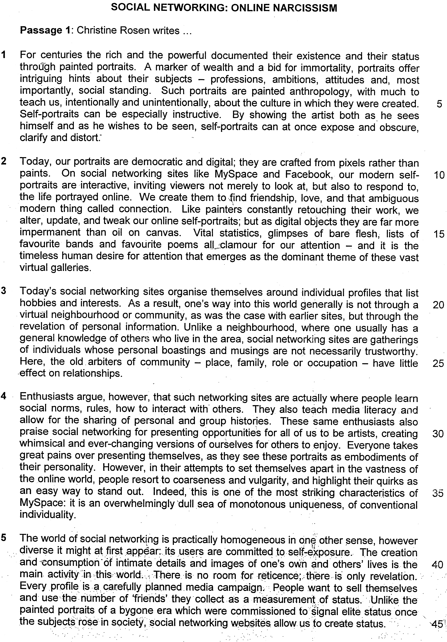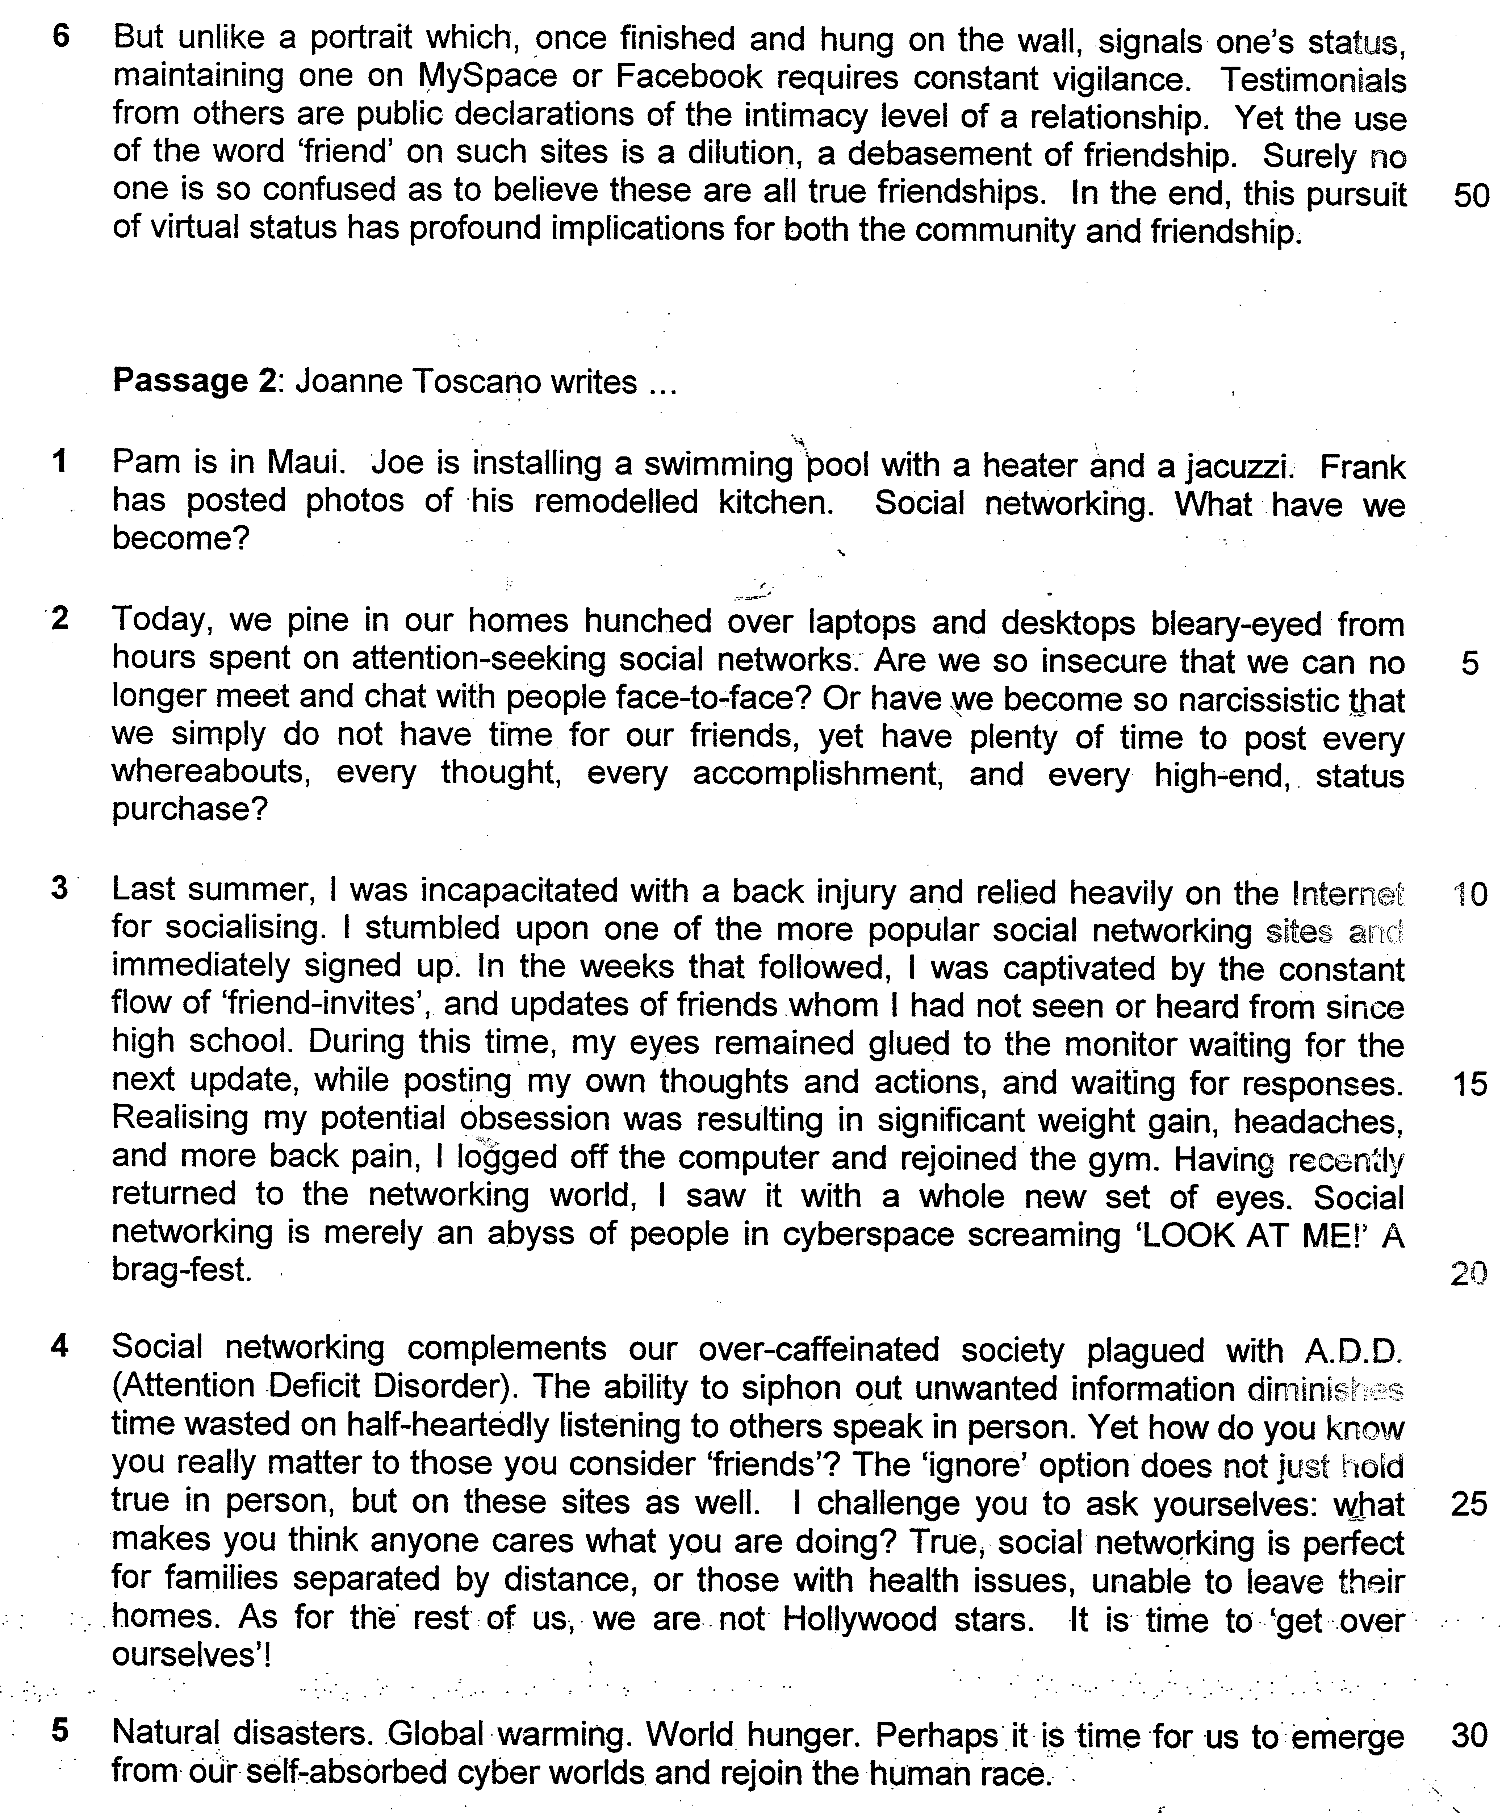

Read the passage in the insert and then answer all the questions which follow below. Note that up to fifteen marks will be given for the quality and accuracy of your use of English throughout this paper.

NOTE: When a question asks for an answer IN YOUR OWN WORDS AS FAR AS POSSIBLE and you select the appropriate material from the passages for your answer, you must still use your own words to express it. Little credit can be given to answers which only copy words or phrases from the passages.

Questions on Passage 1
1. According to Paragraph 1, what ‘hints’ do painted portraits offer about their subjects? Answer in your own words as far as possible.

……………………………………………………………………………………...…

……………………………………………………………………………………...…
………………………………………………………………………………………[2]

2a. What are the differences between modern portraits and portraits of the past according to Paragraph 2? Answer in your own words as far as possible.

…………………………………………………………………………………………

…………………………………………………………………………………………

……………………………………………………………………………………...…
………………………………………………………………………………………[2]

2b. What is the similarity between modern portraits and portraits of the past, according to Paragraph 2? Answer in your own words as far as possible.

…………………………………………………………………………………………
………………………………………………………………………………………[1]

3. Using material from paragraphs 3 and 5, summarise how people present themselves and how they interact with others on social networking sites.

Write your summary in no more than 120 words not counting the opening words which are printed below. Use your own words far as possible.

People present themselves on social networking sites by

………………………..………………………………………………………………..

…………………………………………………………………………………………

…………………………………………………………………………………………
…………………………………………………………………………………………
…………………………………………………………………………………………
…………………………………………………………………………………………

…………………………………………………………………………………………
…………………………………………………………………………………………
…………………………………………………………………………………………
…………………………………………………………………………………………

…………………………………………………………………………………………

…………………………………………………………………………………………
…………………………………………………………………………………………
…………………………………………………………………………………………
…………………………………………………………………………………………
…………………………………………………………………………………………

…………………………………………………………………………………………

…………………………………………………………………………………………
……………………………………………………………………………………… [8]

4. Why does the author put the word ‘friends’ (line 43) in inverted commas? Answer in your own words as far as possible.

…………………………………………………………………………………………
………………………………………………………………………………………[1]

Questions on Passage 2

5. Explain why the author repeats the word ‘every’ in lines 7-8. Answer in your own words as far as possible.

…………………………………………………………………………………………
………………………………………………………………………………………[1]

6. Explain the author’s use of the word ‘merely’ in the phrase “merely an abyss of people in cyberspace screaming ‘LOOK AT ME!’” (line 19)

……………………………………………………………………………………...…

……………………………………………………………………………………...…
………………………………………………………………………………………[2]

7. What aspect of modern life is being criticized when the writer describes our society as ‘over-caffeinated … plagued with A.D.D.’ (line 21)?

…………………………………………………………………………………………
………………………………………………………………………………………[1]

8. According to the writer in lines 26-28, which groups of people have valid reasons to use social networking sites? Use your own words as far as possible.

……………………………………………………………………………………...…

……………………………………………………………………………………...…
………………………………………………………………………………………[2]

9. The writer starts Paragraph 1 and Paragraph 5 with a set of examples each. Explain her purpose of doing this.

……………………………………………………………………………………...…

……………………………………………………………………………………...…
………………………………………………………………………………………[2]

10. Give the meaning of the following words as they are used in the passage. You may write your answer in one word or a short phrase.

a) obscure (Passage 1 line 7) …………………………….…..……….……………

b) overwhelmingly (Passage 1 line 36)……………………….….…..………….…

c) vigilance (Passage 1 line 47)…..……….……………….……….………….……

d) profound (Passage 1 line 51)………….……………………..…………………..

e) obsession (Passage 2 line 16)….…………………….………….……. …….[5]

12. Both Christen Rosen and Joanne Toscano argue that the timeless human desire for attention is now degenerating into an obsessive self-absorption which is fuelled by the new media.

What is your view and to what extent is it challenged or confirmed by their arguments?

…………………………………………………………………………………………

…………………………………………………………………………………………

………………………………………………………………………………………….

………………………………………………………………………………………….

………………………………………………………………………………………….

………………………………………………………………………………………….

…………………………………………………………………………………………..

…………………………………………………………………………………………..

…………………………………………………………………………………………

………………………………………………………………………………………….

…………………………………………………………………………………………

…………………………………………………………………………………………

………………………………………………………………………………………….

………………………………………………………………………………………….

………………………………………………………………………………………….

………………………………………………………………………………………….

…………………………………………………………………………………………..

…………………………………………………………………………………………..

…………………………………………………………………………………………

………………………………………………………………………………………….

…………………………………………………………………………………………

………………………………………………………………………………………….

………………………………………………………………………………………….

………………………………………………………………………………………….

………………………………………………………………………………………….

…………………………………………………………………………………………..

…………………………………………………………………………………………..

…………………………………………………………………………………………

………………………………………………………………………………………….

………………………………………………………………………………………….

………………………………………………………………………………………….

…………………………………………………………………………………………..

…………………………………………………………………………………………..

…………………………………………………………………………………………

…………………………………………………………………………………………

…………………………………………………………………………………………

………………………………………………………………………………………….

………………………………………………………………………………………….

………………………………………………………………………………………….

………………………………………………………………………………………….

…………………………………………………………………………………………..

…………………………………………………………………………………………..

……………………………………………………………………………………… [8]

