GP Term 3 2017 – Comprehension – Topic 9: Environmental Issues – Cities and Environment

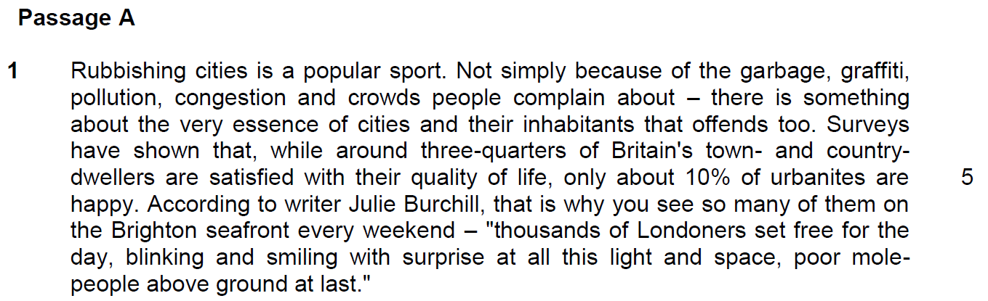

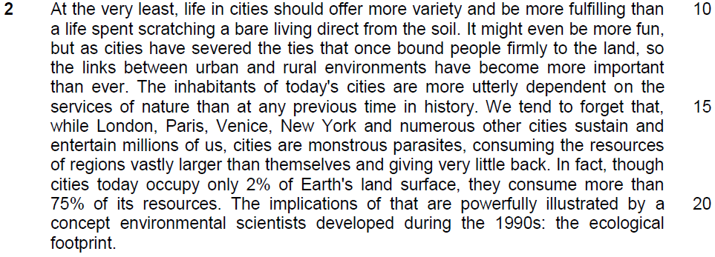

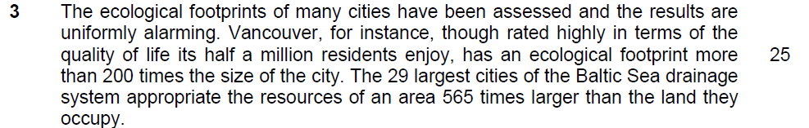

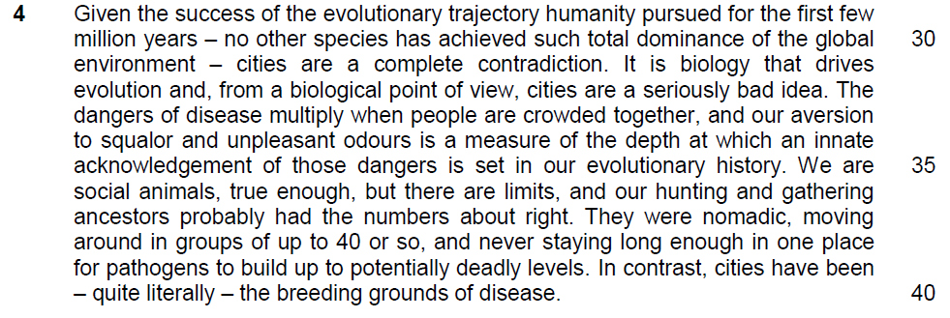
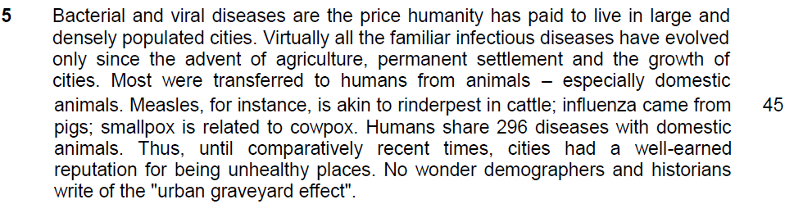

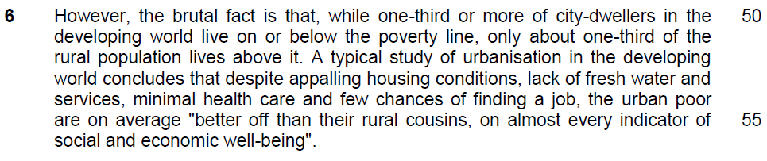

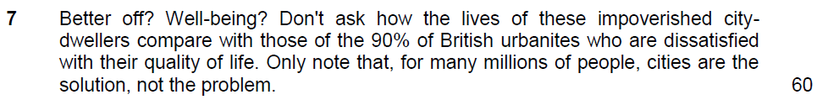

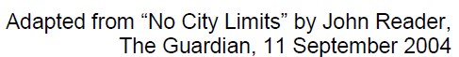

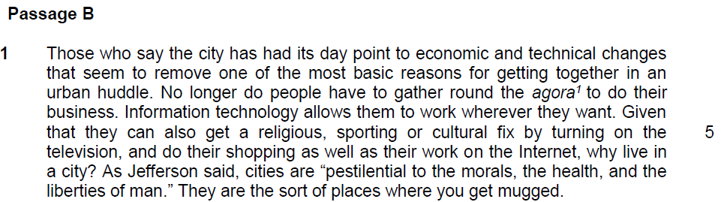

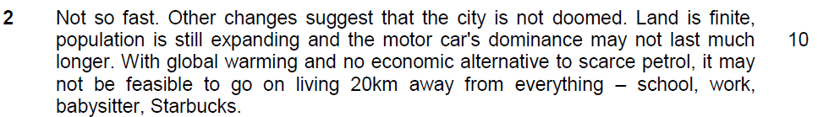

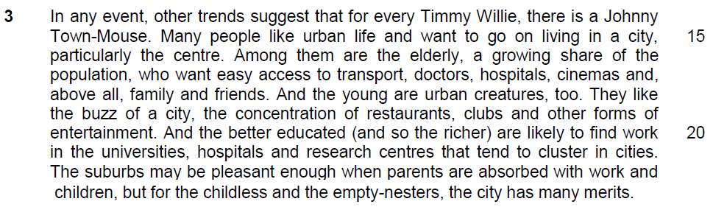

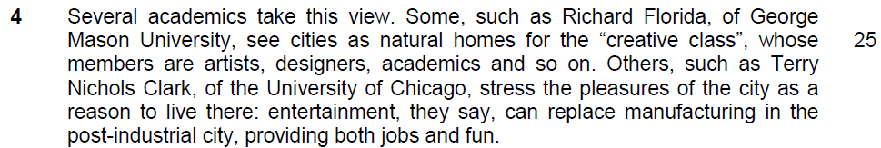

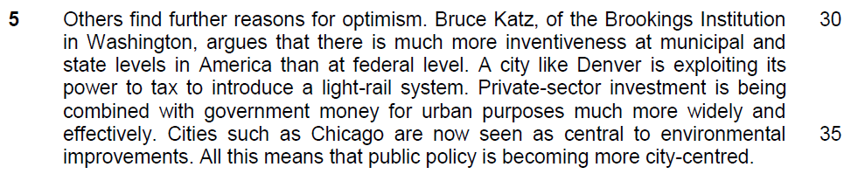

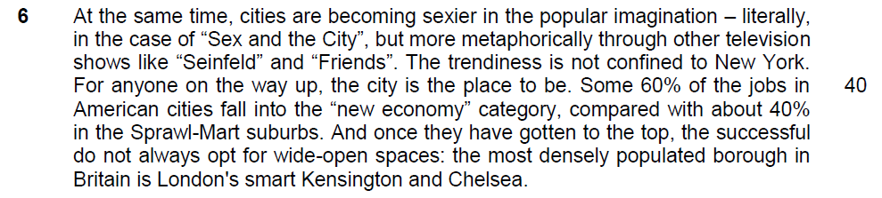

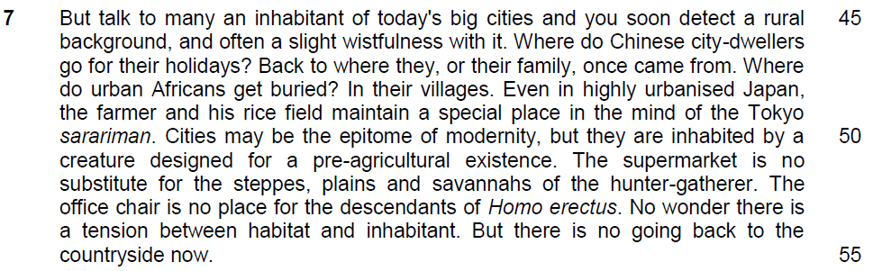

Read the passages in the insert and then answer all the questions. Note that up to fifteen marks will be given for the quality and accuracy of your use of English throughout this paper.

NOTE: When a question asks for an answer IN YOUR OWN WORDS AS FAR AS POSSIBLE and you select the appropriate material from the passage for your answer, you must still use your own words to express it. Little credit can be given to answers which only copy words and phrases from the passages.

From Passage 1
Q1) “set free for the day, blinking and smiling with surprise at all this light and space, poor mole-people above ground at last” (lines 7 – 9). What does this imply about city life? Use your own words as far as possible. [2]

…………………………………………………………………………………………………..

…………………………………………………………………………………………………..

…………………………………………………………………………………………………..

…………………………………………………………………………………………………..

…………………………………………………………………………………………………..

…………………………………………………………………………………………………..

Q2) In what way are cities “monstrous parasites” (line 17)? Use your own words as far as possible. [3]

…………………………………………………………………………………………………..

…………………………………………………………………………………………………..

…………………………………………………………………………………………………..

…………………………………………………………………………………………………..

…………………………………………………………………………………………………..

…………………………………………………………………………………………………..

…………………………………………………………………………………………………..

…………………………………………………………………………………………………..

Q3) Explain, in your own words as far as possible, why “cities are a complete contradiction” (line 31) to the success of human evolution. [2]

…………………………………………………………………………………………………..

…………………………………………………………………………………………………..

…………………………………………………………………………………………………..

…………………………………………………………………………………………………..

…………………………………………………………………………………………………..

…………………………………………………………………………………………………..

Q4) What is meant by the phrase “urban graveyard effect” (line 49)? Use your own words as far as possible. [1]

…………………………………………………………………………………………………..

…………………………………………………………………………………………………..

…………………………………………………………………………………………………..

Q5) Explain the irony of city living. Use material from lines 52 – 56 for your answer. [2]

…………………………………………………………………………………………………..

…………………………………………………………………………………………………..

…………………………………………………………………………………………………..

…………………………………………………………………………………………………..

…………………………………………………………………………………………………..

From Passage B
Q6i) Explain the meaning of “the city has had its day” (line 1). [1]

…………………………………………………………………………………………………..

…………………………………………………………………………………………………..

…………………………………………………………………………………………………..

Q6ii) What are the reasons cited by those who say that the city “has had its day” (line 1)? Use your own words as far as possible. [2]

…………………………………………………………………………………………………..

…………………………………………………………………………………………………..

…………………………………………………………………………………………………..

…………………………………………………………………………………………………..

…………………………………………………………………………………………………..

…………………………………………………………………………………………………..

Q7) What is the tone intended by the author when he included “Starbucks” (line 13) in his list of “everything” (line 12)? [1]

…………………………………………………………………………………………………..

…………………………………………………………………………………………………..

…………………………………………………………………………………………………..

Q8) Why does the writer mention a series of examples in lines 46 to 48? [1]

…………………………………………………………………………………………………..

…………………………………………………………………………………………………..

…………………………………………………………………………………………………..

Summary Question
Q9) Using material from paragraphs 3 – 6, summarise the factors which indicate that cities are not doomed (Passage B, line 9).

Write your summary in no more than 120 words, not counting the opening words which are printed below. Use your own words as far as possible. [7]

The city is not doomed because
Lifted Answer | Suggested Answer
many people like urban life and want to go on living in the city (l.15)

the elderly, a growing share of the population, want easy access to transport, doctors, hospitals,

family and friends (l.16-18)

the young like the buzz of the city, the concentration of restaurants, clubs and other forms of entertainment (l.19-20)… pleasures of the city (l.27)…fun (l.29)

for the childless and the empty-nesters, the city has many merits (l.22-23)

the better educated (and so the richer) are likely to find work… (20-21)… providing jobs (l.29) …some 60% of American jobs in American cities fall into the “ new economy” (l.40-41)

cities as natural homes for the “creative class…artists, designers,”(l.25-26)

much more inventiveness at the municipal and state level than at the federal level… cities like Chicago are now seen as central to environmental improvements … public policy is becoming more city-centred (l.31- 36)

private sector investment …combined with government money for urban purposes more widely and effectively (l.33-35)
cities are becoming sexier in the popular imagination…through television shows… trendiness (l.37 – 39)

for anyone on their way up, the city is the place to be (l.40)

Application Question
Q10) In Passage A, Reader argues that cities present a host of environmental and health problems while in Passage B, the writer argues that “the city is not doomed.” (line 9).

Are you more optimistic or pessimistic about city living?

In your answer, assess some of the issues raised by both writers and support your views with examples drawn from your own observations and experiences. [8]

…………………………………………………………………………………………………..

…………………………………………………………………………………………………..

…………………………………………………………………………………………………..

…………………………………………………………………………………………………..

…………………………………………………………………………………………………..

…………………………………………………………………………………………………..

…………………………………………………………………………………………………..

…………………………………………………………………………………………………..

…………………………………………………………………………………………………..

…………………………………………………………………………………………………..

…………………………………………………………………………………………………..

…………………………………………………………………………………………………..

…………………………………………………………………………………………………..

…………………………………………………………………………………………………..

…………………………………………………………………………………………………..

…………………………………………………………………………………………………..

…………………………………………………………………………………………………..

…………………………………………………………………………………………………..

…………………………………………………………………………………………………..

…………………………………………………………………………………………………..

…………………………………………………………………………………………………..

…………………………………………………………………………………………………..

…………………………………………………………………………………………………..

…………………………………………………………………………………………………..

…………………………………………………………………………………………………..

…………………………………………………………………………………………………..

…………………………………………………………………………………………………..

…………………………………………………………………………………………………..

…………………………………………………………………………………………………..

…………………………………………………………………………………………………..

…………………………………………………………………………………………………..

…………………………………………………………………………………………………..

…………………………………………………………………………………………………..

…………………………………………………………………………………………………..

…………………………………………………………………………………………………..

…………………………………………………………………………………………………..

…………………………………………………………………………………………………..

…………………………………………………………………………………………………..

…………………………………………………………………………………………………..

…………………………………………………………………………………………………..

…………………………………………………………………………………………………..

…………………………………………………………………………………………………..

…………………………………………………………………………………………………..

…………………………………………………………………………………………………..

…………………………………………………………………………………………………..

