GP Term 4 2017 – Comprehension Topic 4: International Issues – Globalization on Cultural Change

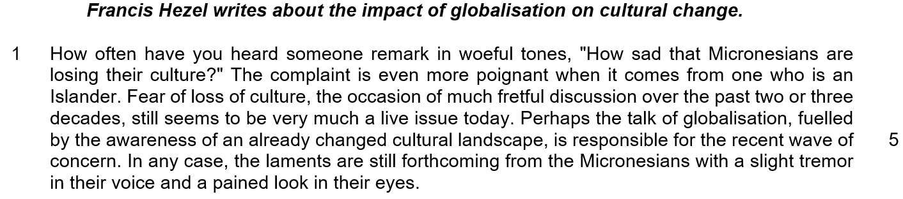

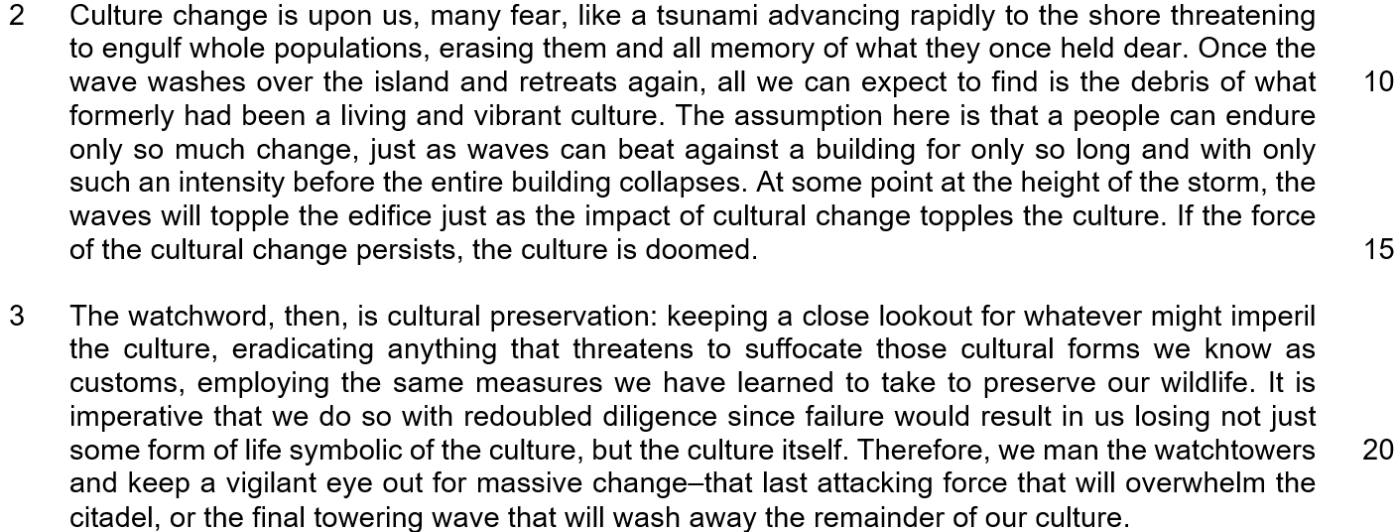

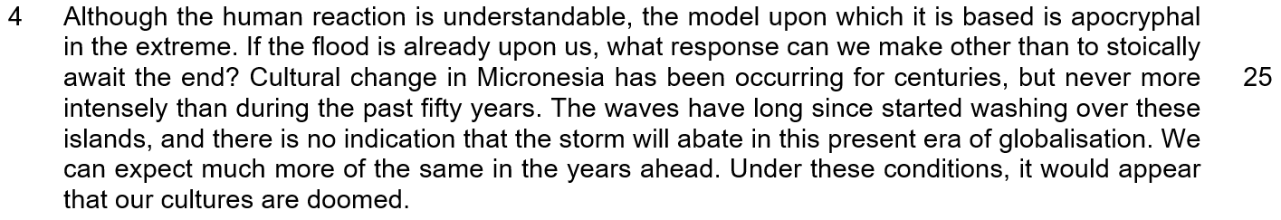

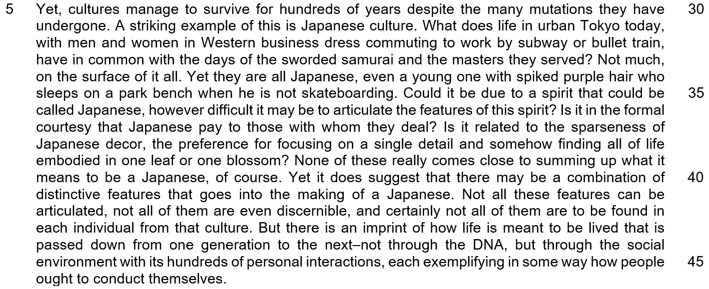

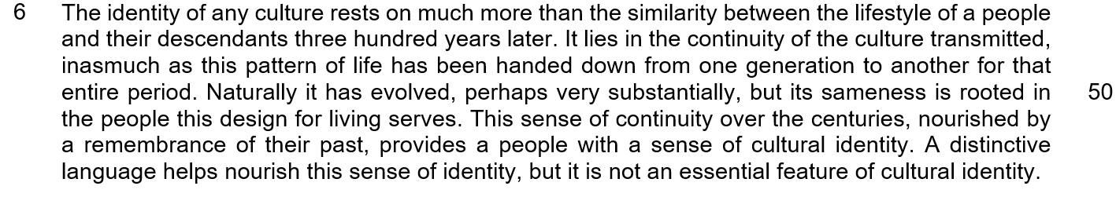

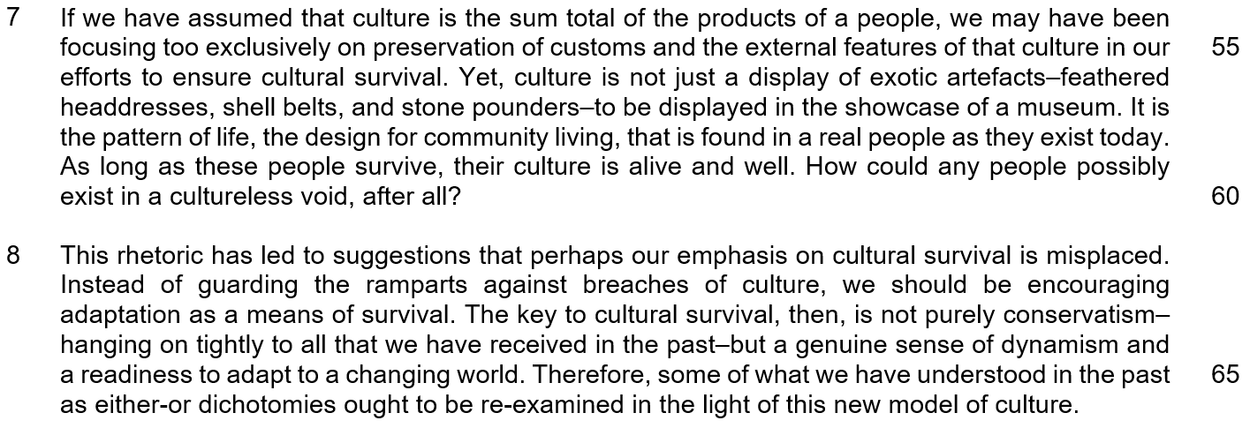

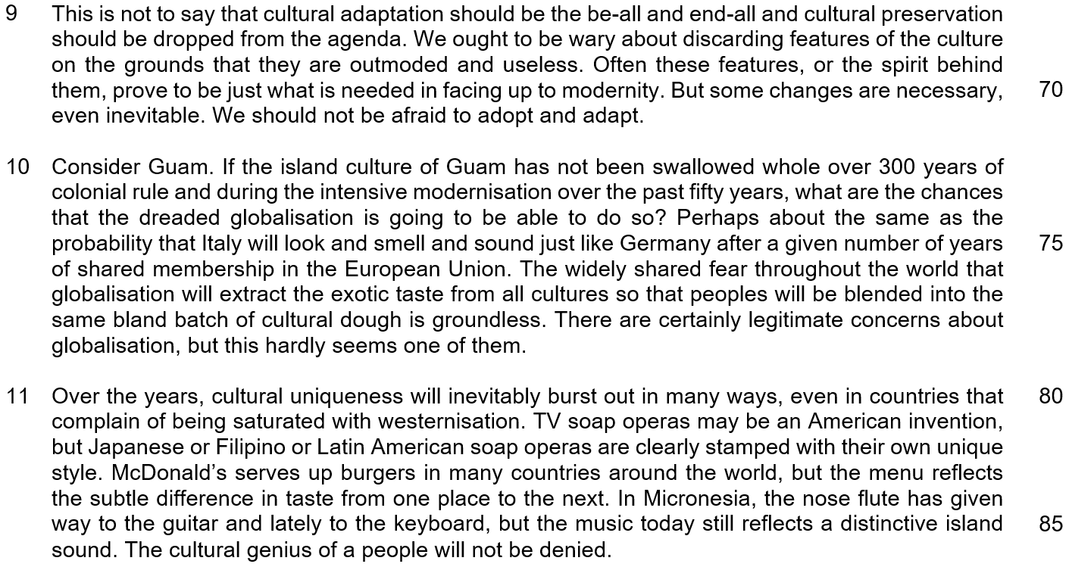

NOTE: When a question asks for an answer IN YOUR OWN WORDS AS FAR AS POSSIBLE, and you select the appropriate material from the passage for your answer you must still use your own words to express it. Little credit can be given to answers which only copy words and phrases from the passage.

Q1) What does the word ‘fretful’ (line 3) tell us about the ‘discussion’ (line 3)? Use your own words as far as possible. [1]

……………………………………………………………………………………………………………………………………

……………………………………………………………………………………………………………………………………

Q2) Explain what the author means by the “recent wave of concern” in line 6. [2]

……………………………………………………………………………………………………………………………………

……………………………………………………………………………………………………………………………………

……………………………………………………………………………………………………………………………………

……………………………………………………………………………………………………………………………………

Q3) In paragraph 2, what two similarities does the author see between cultural change and a tsunami? Use your own words as far as possible. [2]

……………………………………………………………………………………………………………………………………

……………………………………………………………………………………………………………………………………
……………………………………………………………………………………………………………………………………

……………………………………………………………………………………………………………………………………
Q4) According to the author in Paragraph 3, what do we need to do to preserve culture? Use your own words as far as possible. [2]

……………………………………………………………………………………………………………………………………

……………………………………………………………………………………………………………………………………

……………………………………………………………………………………………………………………………………

……………………………………………………………………………………………………………………………………

Q5) What is the author’s purpose in referring to the ‘citadel’ in line 22? Use your own words as far as possible. [2]

……………………………………………………………………………………………………………………………………

……………………………………………………………………………………………………………………………………

……………………………………………………………………………………………………………………………………

……………………………………………………………………………………………………………………………………

Q6) What does the question in lines 24-25 suggest about the way that cultural change has been perceived? [1]

……………………………………………………………………………………………………………………………………

……………………………………………………………………………………………………………………………………

Q7) Explain the author’s use of the word “even” in line 34. Use your own words as far as possible. [1]

……………………………………………………………………………………………………………………………………

……………………………………………………………………………………………………………………………………

Q8) In Paragraph 9, what does the author consider to be unjustified reasons for discarding features of a culture? [1]

……………………………………………………………………………………………………………………………………

……………………………………………………………………………………………………………………………………

Q9) What is the author implying when he refers to Italy and Germany in paragraph 10? [2]

……………………………………………………………………………………………………………………………………

……………………………………………………………………………………………………………………………………

……………………………………………………………………………………………………………………………………

……………………………………………………………………………………………………………………………………

Q10) In line 94, the author claims that “the cultural genius of a people will not be denied.” How does each of the examples in paragraph 11 illustrate his assertion? [3]

……………………………………………………………………………………………………………………………………

……………………………………………………………………………………………………………………………………

……………………………………………………………………………………………………………………………………

……………………………………………………………………………………………………………………………………

……………………………………………………………………………………………………………………………………

……………………………………………………………………………………………………………………………………

Q11) Using material from Paragraphs 5-9 only (lines 30-71), summarize what the author has to say about what culture is made up of, why cultures survive despite change and how we should respond to cultural change.

Write your summary in no more than 120 words, not counting the opening words which are printed below. Use your own words as far as possible. [8]

Culture is made up of …

……………………………………………………………………………………………………………………………………

……………………………………………………………………………………………………………………………………

……………………………………………………………………………………………………………………………………

……………………………………………………………………………………………………………………………………

……………………………………………………………………………………………………………………………………

……………………………………………………………………………………………………………………………………

……………………………………………………………………………………………………………………………………

……………………………………………………………………………………………………………………………………

……………………………………………………………………………………………………………………………………

……………………………………………………………………………………………………………………………………

……………………………………………………………………………………………………………………………………

……………………………………………………………………………………………………………………………………

……………………………………………………………………………………………………………………………………

……………………………………………………………………………………………………………………………………

……………………………………………………………………………………………………………………………………

……………………………………………………………………………………………………………………………………

……………………………………………………………………………………………………………………………………

……………………………………………………………………………………………………………………………………

……………………………………………………………………………………………………………………………………

……………………………………………………………………………………………………………………………………

……………………………………………………………………………………………………………………………………

……………………………………………………………………………………………………………………………………
Q12) Application Question (AQ)
In this article, Francis Hezel believes that globalization will affect but not wipe out/cause a loss of/lead to the loss of the cultural identity of a people (community). How far would you agree with Francis Hezel’s observations? Relate your opinions to you and your society. [10]

……………………………………………………………………………………………………………………………………

……………………………………………………………………………………………………………………………………

……………………………………………………………………………………………………………………………………

……………………………………………………………………………………………………………………………………

……………………………………………………………………………………………………………………………………

……………………………………………………………………………………………………………………………………

……………………………………………………………………………………………………………………………………

……………………………………………………………………………………………………………………………………

……………………………………………………………………………………………………………………………………

……………………………………………………………………………………………………………………………………

……………………………………………………………………………………………………………………………………

……………………………………………………………………………………………………………………………………

……………………………………………………………………………………………………………………………………

……………………………………………………………………………………………………………………………………

……………………………………………………………………………………………………………………………………

……………………………………………………………………………………………………………………………………

……………………………………………………………………………………………………………………………………

……………………………………………………………………………………………………………………………………

……………………………………………………………………………………………………………………………………

……………………………………………………………………………………………………………………………………

……………………………………………………………………………………………………………………………………

……………………………………………………………………………………………………………………………………

……………………………………………………………………………………………………………………………………

……………………………………………………………………………………………………………………………………

……………………………………………………………………………………………………………………………………

……………………………………………………………………………………………………………………………………

……………………………………………………………………………………………………………………………………

……………………………………………………………………………………………………………………………………

……………………………………………………………………………………………………………………………………

……………………………………………………………………………………………………………………………………

……………………………………………………………………………………………………………………………………

……………………………………………………………………………………………………………………………………

……………………………………………………………………………………………………………………………………

……………………………………………………………………………………………………………………………………

……………………………………………………………………………………………………………………………………

……………………………………………………………………………………………………………………………………

……………………………………………………………………………………………………………………………………

……………………………………………………………………………………………………………………………………

……………………………………………………………………………………………………………………………………

……………………………………………………………………………………………………………………………………

……………………………………………………………………………………………………………………………………

……………………………………………………………………………………………………………………………………

……………………………………………………………………………………………………………………………………

……………………………………………………………………………………………………………………………………

……………………………………………………………………………………………………………………………………

……………………………………………………………………………………………………………………………………

