GP Term 3 2017 – Comprehension – Topic 9: Environmental Issues – Cities and Environment

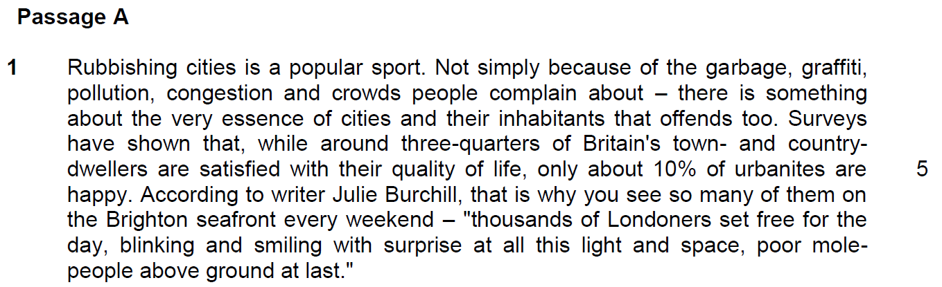

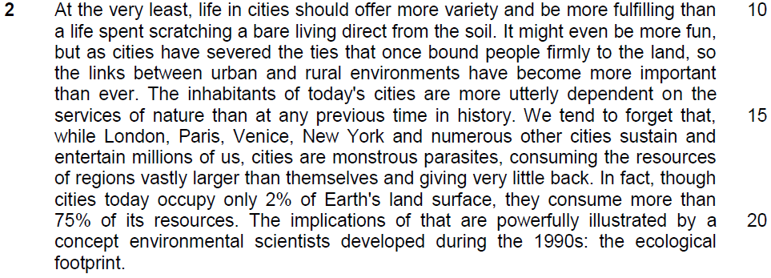

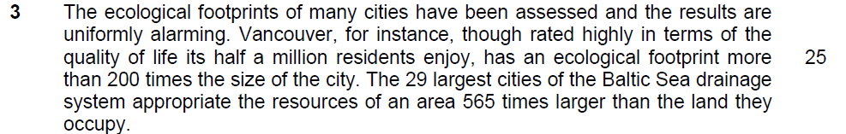

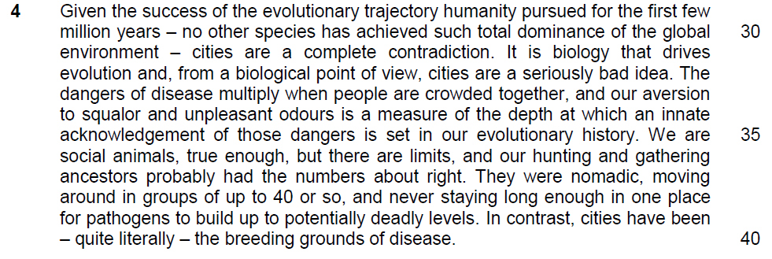
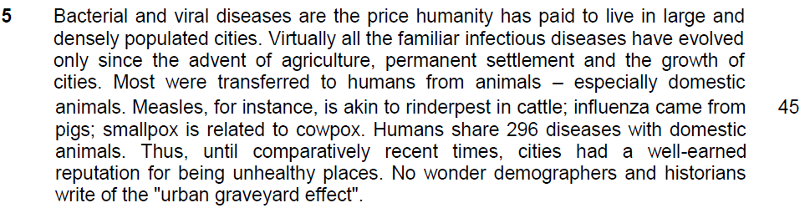

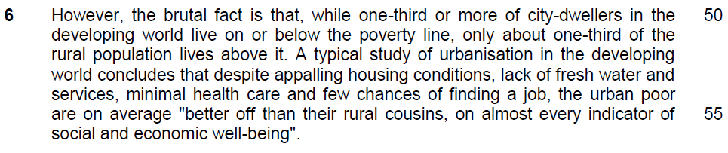

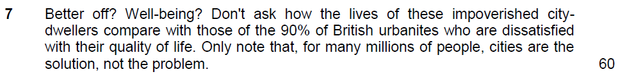

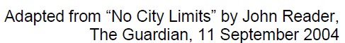

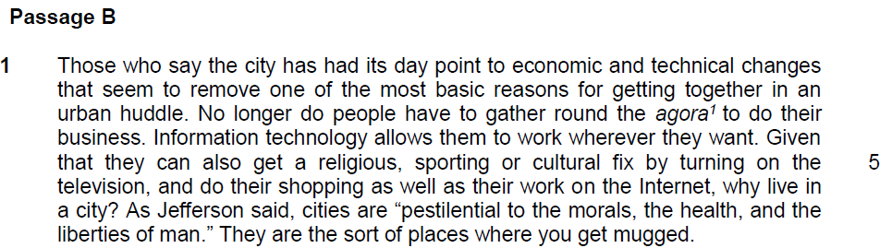

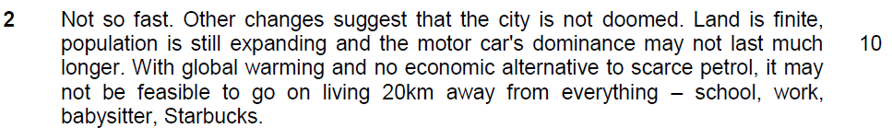

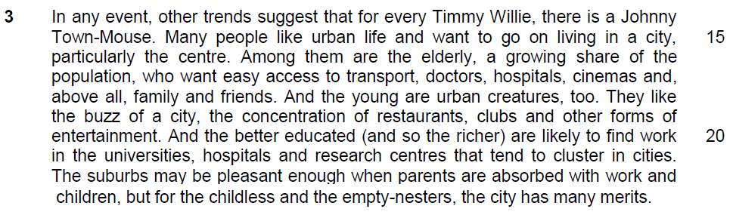

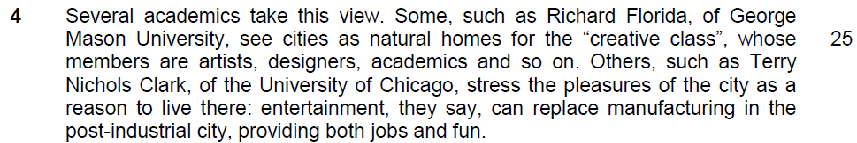

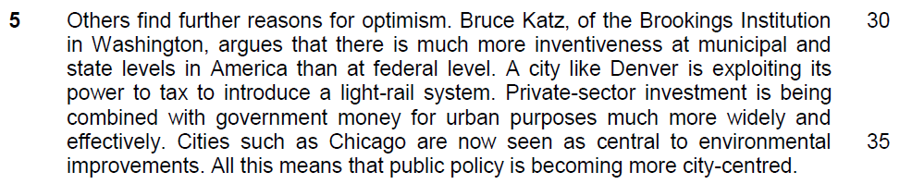

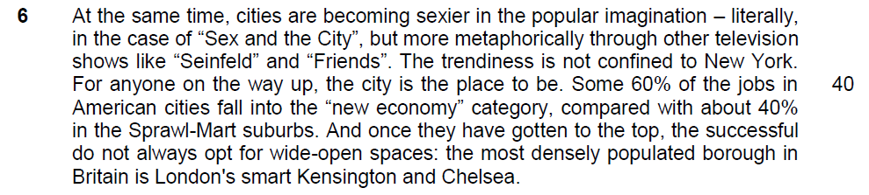

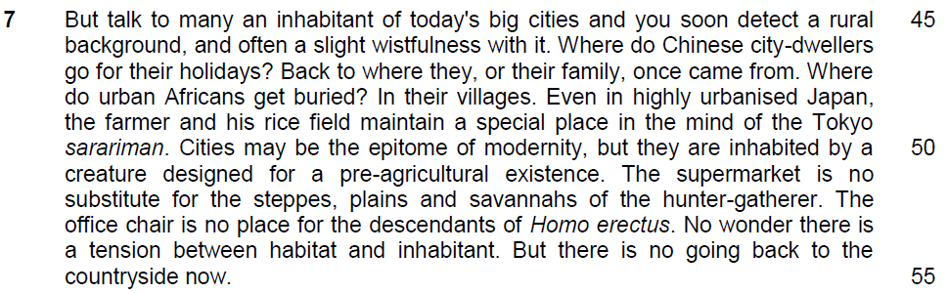

Suggested Answers

From Passage 1
Q1) “set free for the day, blinking and smiling with surprise at all this light and space, poor mole-people above ground at last” (lines 7 – 9). What does this imply about city life? Use your own words as far as possible. [2]

From the Passage
set free … surprise at all this light and space, poor mole-people above ground at last (l.7-9) – to be inferred

Paraphrased Answer
description
City life appears to be stifling/ confining/ restrictive/ claustrophic / oppressive/ suffocating/ much like a prison/ confined cell/ overwhelming/ hectic and full of stress/ pressurizing/ people feel imprisoned/ shackled/ entrapped by the pressures of city life.
implication
The city is overcrowded, overly congested/ densely populated/ too many people crammed/ packed/ trapped in a small space.
City life also seems to grey/ dull/ dreary/ gloomy/ dreary/ depressing due to the poor living conditions/ dirt and grime/ pollution.

Q2) In what way are cities “monstrous parasites” (line 17)? Use your own words as far as possible. [3] monstrous – huge / feed off, exploitative, damaging

From the Passage
Consuming the resources of regions vastly larger than themselves, giving very little back (l.17-18)

Though cities today occupy only 2% of the Earth’s land surface, they consume more than 75% of its resources (l.18-20)

Giving very little back

Paraphrased Answer
Both parasites and cities are small in size, but just as parasites devour/ feed on their hosts voraciously despite their size, cities utilize a massive amount of resources from other bigger regions.

Both also do this at the expense of the welfare of their hosts/ without benefiting their hosts.

Just as the parasites deplete the nutrients of their hosts, weakening them, cities contribute to the depletion of resources and caused environmental damage to other regions

Q3) Explain, in your own words as far as possible, why “cities are a complete contradiction” (line 31) to the success of human evolution. [2]

From the Passage
Hunting and gathering ancestors had the numbers about right, nomadic, never staying long enough in one place for pathogens to build up to potentially deadly levels (l.37-39)

but cities… the breeding grounds of disease (l.39-40).

Dangers of disease multiply when people are crowded together… squalor & unpleasant odours (l.33-34)

Paraphrased Answer
In the past humans did not reside in one place long enough for diseases to spread, contributing to the success of human survival. This is opposite to/ in conflict with the current congested, dirty living conditions in the city which are conducive to the spread of epidemics.

Q4) What is meant by the phrase “urban graveyard effect” (line 49)? Use your own words as far as possible. [1]

From the Passage
Bacterial and viral diseases are the price humanity has paid to live in large and densely populated cities … share 296 diseases with animals (l.41-47)

Paraphrased Answer
It means the outcome of living in cities can be hazardous to health / results in many illnesses being transmitted easier to the dwellers, resulting in many deaths.

Q5) Explain the irony of city living. Use material from lines 52 – 56 for your answer. [2] expectation differs from outcome

From the Passage
despite appalling housing conditions, lack of fresh water and services, minimal health care and few chances of finding a job

the urbans are on average “better off than their rural cousins, on almost every indicator or social and economic well-being

Paraphrased Answer
Given the poor living conditions in the city, one would assume/ presuppose/ expect city dwellers to have a low quality of life. Instead/ however, contrary to expectation, they seem to enjoy a better standard of living and quality of life relative to those in rural areas.

From Passage B
Q6i) Explain the meaning of “the city has had its day” (line 1). [1]
had its day – it had its prime moments
Inferred Answer
Urban living is no longer popular / practical/ the city has outlived its usefulness/ no longer serves its purpose/ no longer an ideal or good place to live in / has lost its significance/ less attractive/ less appealing / not as desirable/ past its prime/ on the decline.

Q6ii) What are the reasons cited by those who say that the city “has had its day” (line 1)? Use your own words as far as possible. [2]

From the Passage
No longer get together in an urban huddle/ gather round the agora to do their business (l.3-4)

Info technology allows them to work wherever they want – get their religious, sporting or cultural fix by turning on the television, do their shopping… work on the internet (l.4-6)

Pestilential to morals, the health and liberties of man, sort of places you get mugged (l.7-8)

Paraphrased Answer
The city seems to have lost its function as a meeting place/hub for people to carry out transactions since technology now enables people to work and carry out their daily lives anywhere, independently. The city is no longer an ideal place to live in as it is full of vices, crime and diseases.

Q7) What is the tone intended by the author when he included “Starbucks” (line 13) in his list of “everything” (line 12)? [1]

Inferred Answer
The author was taking a tongue-in-cheek / humorous / wry/ light hearted/ amused/ cheeky look at the essentials of modern life. The writer’s tone is one of resignation as trivialities are now seen as essentials

Q8) Why does the writer mention a series of examples in lines 46 to 48? [1]
From the Passage
Where do Chinese city-dwellers go for their holidays? Back to where they, or their family, once came from. Where do urban Africans get buried?

Paraphrased Answer
- To emphasise/ highlight/ drive home the point/ reinforce his point
Point 2
our sense of loss and longing for the rural lifestyle
or
our affinity for/ desire to re-connect with/ go back to our “rural background”/ roots/ the countryside
Summary Question
Q9) Using material from paragraphs 3 – 6, summarise the factors which indicate that cities are not doomed (Passage B, line 9).

Write your summary in no more than 120 words, not counting the opening words which are printed below. Use your own words as far as possible.

The city is not doomed because

Lifted Answer | Suggested Answer
many people like urban life and want to go on living in the city (l.15)  the elderly, a growing share of the population, want easy access to transport, doctors, hospitals,  family and friends (l.16-18)  the young like the buzz of the city, the concentration of restaurants, clubs and other forms of entertainment (l.19-20)… pleasures of the city (l.27)…fun (l.29)  for the childless and the empty-nesters, the city has many merits (l.22-23)  the better educated (and so the richer) are likely to find work… (20-21)… providing jobs (l.29) …some 60% of American jobs in American cities fall into the “ new economy” (l.40-41)  cities as natural homes for the “creative class…artists, designers,”(l.25-26)  much more inventiveness at the municipal and state level than at the federal level… cities like Chicago are now seen as central to environmental improvements … public policy is becoming more city-centred (l.31- 36)  private sector investment …combined with government money for urban purposes more widely and effectively (l.33-35)  cities are becoming sexier in the popular imagination…through television shows… trendiness (l.37 – 39)  for anyone on their way up, the city is the place to be (l.40) | Many people still prefer/desire/ opt/ choose to live in the city/ still a popular choice for many people  The city puts the elderly within easy reach of good infrastructure, services and facilities.  and loved/ close ones  The young enjoy the vibrant city life with its diversity of leisure/ recreational activities.  The city thus offers many benefits especially to those with few or no family commitments  More employment opportunities  Cities have a rich cultural heritage/ culturally vibrant/ rich in the arts and culture  City policy makers have more innovative ideas to improve city living conditions  More private and public funds are channelled for these improvements  cities also have a hip/ cool image thanks to the media  it is the preferred/obvious choice for the upwardly mobile/ those seeking a better life/ betterment/improvement
Application Question
Q10) In Passage A, Reader argues that cities present a host of environmental and health problems while in Passage B, the writer argues that “the city is not doomed.” (line 9).

Are you more optimistic or pessimistic about city living?

In your answer, assess some of the issues raised by both writers and support your views with examples drawn from your own observations and experiences.

The two passages propose opposing viewpoints on city living today. I am more optimistic about city living due to the multitude of benefits that one can experience with being a city dweller.

Reader, in passage A, states that "cities have been - quite literally - the breeding grounds for disease". As cities are densely populated, disease can spread and be transmitted quickly throughout the population, which is why one could be pessimistic about city life. However, i choose to be an optimist because despite the speed that the disease transcends the population as there is an abundance of hospitals and clinics that one could quickly get treatment from. Urbanised cities provide much easier access to healthcare, as well as the proper precautionary measures and solutions the society needs to take to combat the spread of contagion. For example, Singapore has fought against contagious diseases that became epidemics such as SARS and H1N1. They also informed the public on how to prevent the Zika and Ebola viruses in recent years, to ensure that those diseases did not spread to become epidemics in the country. There are authorities that conduct checks in homes for mosquito breeding sites to help decrease the likelihood for a dengue virus outbreak in the community as well, and they label areas by colour to inform the public if they may be staying in a Aedes mosquito hotspot. These are advantages of a city life in prevention of viral outbreaks and epidemics, which allows me to be optimistic about it.

On the other hand, the writer of passage B states that living in the urbanised context, "the city has many merits", as there is easy access to many different amenities, including work, entertainment, housing and so on. There is a high level of connectivity, especially with transport systems that run throughout cities, and the close proximity of a variety of buildings with different purposes. This allows for convenience and efficiency especially in the modern society where many individuals have busy schedules that are packed with different activities from dawn till evening. Some examples in Singapore are public swimming pools, community centres, many schools that are spread out all across the country, shopping malls and the list goes on. With all these different places that people can easily go to and enrich their lives, it goes to show that it is a benefit that the shift to city dwelling has given to us. Hence, I am optimistic about city life.

In conclusion, like the writer of passage B, I am optimistic about city living.

Application Question
Q10) In Passage A, Reader argues that cities present a host of environmental and health problems while in Passage B, the writer argues that “the city is not doomed.” (line 9).

Are you more optimistic or pessimistic about city living? effects of city life

In your answer, assess some of the issues raised by both writers and support your views with examples drawn from your own observations and experiences.

Suggested approach
Are you more optimistic or pessimistic about city living?
1. Choose a view – optimistic (agree with writer from The Economist) OR
– pessimistic (agree with Reader)

Assess some of the arguments made by both writers.
1. Identify one important argument raised by Reader and the writer from The Economist for discussion.

2. Evaluate the argument and provide reasons why you think is optimistic or pessimistic

Support your views with examples drawn from your own observations and experiences.
1. Substantiate your reasons with evidence i.e. provide relevant, concrete examples. These examples need not be from your society.

How to develop the argument:
stand: which view
effect: how it affects your view
- quote from the passage
- explain the effect
- explain how this effect is seen from your experience in Singapore / observation of other countries
- describe examples

- the concentration of facilities and amenities
- convenience and comfort
- how the facilities we have will give us a better living – efficient and very near to your needs, safe and sound, upgraded and maintained
- examples

- How the question is asked?

take the reason from the passage to make your argument
relate the situation of your observation
show the effect to support your discussion

Example – incidents, concept or theory, policy, institutions, reports (PISA)
- state the purpose of this example to support your argument

Why I am more optimistic
a) Passage B
1) …it may not be feasible to go on living 20km away from everything (l.12-14) … easy access to transport, doctors, hospitals, cinemas and above all family and friends (l.17-18)

b) Explanation and Evaluation
Stand: I am more optimistic about city living and thus agree largely with the writer from The Economist because city life does indeed provide a host of benefits and conveniences.

Explanation: The amenities are located in close proximity, and this is further enhanced by the efficient transportation system which provides fast and convenient access. Health facilities and loved ones are also nearby. (effects – easy life, build good relationship)

c) Examples
1) Moscow, Russia: one of the most precise subway in the world, carries over 8.2 million passengers on an average weekday.

2) Paris, France: the Paris Metro has one of the best coverage, average distance to a station from any point is only about 500 meters.
3) Atlanta, USA: parks, subway stations, museums, world’s largest aquarium, movie theatres, world’s largest drive-in, universities all located downtown.

c) Passage B
2) …like the buzz of a city, the concentration of restaurants, clubs and other forms of entertainment (l. 19-20) …pleasures of the city… entertainment, they say, can replace manufacturing in the post-industrial city, providing both jobs and fun (l. 27-29)

b) Explanation and Evaluation
Explanation: City life is often vibrant and there is a diversity of leisure activities which one can engage in to relax and unwind. Some cities are also rich in cultural heritage.
(effects – exciting, interesting an enriching life for the individuals)

c) Examples
1) Rome, Italy: one can be exposed to the cultural heritage through ancient monuments, medieval and Renaissance buildings and fountains, museums. It addition, it is also renowned for its many fine restaurants and cafes, a good nightlife, and lively streets and squares. It is also an international center of fashion and the film industry.

2) Turin, Italy: major cultural hub with excellent museums, elegant shops, and good restaurants. One can view baroque architecture, historic palaces, cafes, artisan workshops, and arcades.

3) Birmingham, UK: internationally recognised as a leader in leisure, entertainment, business, shopping, and sport. Presence of modern shopping arcades, diverse pubs, clubs and restaurants and fine museums, theatres and art galleries. £500 million Bullring mall in city centre.

a) Passage B
3) …likely to find work in the universities, hospitals and research centres that tend to cluster in cities (l. 20-21) …for anyone on the way up, the city is the place to be (l. 40)

b) Explanation and Evaluation
Explanation: The city offers various job opportunities, both for the highly educated and also for people seeking progress and who wish to experience upward social mobility.

c) Examples
Austin, Texas, USA: job growth between 2004 and 2008 was 14.8%. Strong growth in service sectors like education and health, leisure and hospitality.

a) Passage B
4) …private-sector investment is being combined with government money for urban purposes much more widely and effectively. Cities... now seen as central to environmental improvements(l.33-36)

b) Explanation and Evaluation
Explanation: Due to more sources, and a larger pool of funding, the living conditions in cities are now vastly improved through the efforts of concerned policy makers.

c) Examples
1) Surat, Bombay, India: in 1994, 40% of its 2.2 million people lived in slums, without drainage and sanitation. There was outbreak of plague following a flood, migrant workers fled, thousands of businesses closed. Only 40% of the daily garbage was cleared. Now, 97% of the daily garbage is cleared, morbidity fell by 65% within two-and-a-half years. Pledge to extend sanitation to every corner of the city with piped water, a result of two schemes costing $90 million.

2) Naga, Philippine: leaped from third-class city in 1988, in terms of income and services, to first-class status in 1990. Of 5500 squatter families, 4668 now own land. Number of concrete roads and households with running water doubled between 1988 and 1996, and garbage collection efficiency rose from 29% to 85%.

a) Passage A
1) … cities are monstrous parasites, consuming the resources of regions vastly larger than themselves and giving very little back (l. 17-18) … the ecological footprints of many cities have been assessed and the results are uniformly alarming (l. 23-24)

b) Explanation and Evaluation
Evaluation: I must concede though, that Reader does have some valid concerns about city living.

Explanation: Due to residential density, transportation systems and electricity consumption, cities utilize a large amount of resources and contribute greatly towards pollution, thus leaving a large carbon footprint behind.

c) Examples
1) Linfen, China: soot-blackened city, air is filled with burning coal. Automobile and industrial emissions main source of coal and particulates pollutants.

2) La Oroya, Peru: 99% of children have blood levels that exceed acceptable limits, their average lead level was triple the WHO limit.

3) Los Angeles, California, USA: consumes 235438 MkWh (millions of kilowatt hours).

4) Lexington, Kentucky, USA: 3.455 per capita carbon emission from transportation and residential energy use (largest carbon footprint).

a) Passage A
2) … dangers of disease multiply when people are crowded together (l. 33) … breeding grounds of disease (l.40) …bacterial and viral diseases are the price humanity has paid to live in large and densely populated cities (l. 41-42)… urban graveyard effect (l.49)

b) Explanation and Evaluation
Explanation: City life is potentially hazardous to health as the close proximity of humans facilitates the transmission and rapid spread of diseases, some of which could be fatal.

c) Examples
1) Philadelphia, USA: yellow fever epidemic killed as many as 5000 people, roughly 10% of the population, in 1793.

2) Singapore: 144 of Singapore’s 206 probable cases of SARS have been linked to contact with only 5 individuals.

3) Hong Kong: 2.7 secondary infections of SARS were generated on average per case at the start of the epidemic. Transmission rates fell after efforts made to reduce population contact rates, among other measures.

a) Counterarguments to ideas in Passage A
1) … cities are monstrous parasites, consuming the resources of regions vastly larger than themselves and giving very little back (l. 17-19) … the ecological footprints of many cities have been assessed and the results are uniformly alarming (l. 23-24)

b) Explanation and Evaluation
Evaluation: However, his concerns and pessimism can be easily allayed and dismissed, especially if we take into consideration developments in today’s world. Hence, I firmly believe that city life should be viewed with optimism instead of pessimism.

Explanation: There is a greater awareness of the carbon footprint which cities are leaving behind and hence, there is increased and sustained effort by community and global leaders in tackling this issue. There is now the push to go-green and certain cities are testament to this success. This is manifested in sustainable cities, or eco-cities. These are cities designed with consideration of environmental impact, inhabited by people dedicated to minimization of required inputs of energy, water and food, and waste output of heat, air pollution. A sustainable city can feed itself with minimal reliance on the surrounding countryside, and power itself with renewable sources of energy. The crux of this is to create the smallest possible ecological footprint, and to produce the lowest quantity of pollution possible, to efficiently use land; compost used materials, recycle it or convert waste-to-energy, and thus the city’s overall contribution to climate change will be minimal.

c) Examples
1) Calgary, Canada: city with the best eco-ranking based on water availability and drinkability, waste removal, quality of sewage systems, air pollution and traffic congestion.

2) Oakland, California, USA: 17% of power produced from renewable energy. Renewable energy sources produce electricity with no global climate-changing greenhouse gas emissions or regional air pollution that comes from burning fossil fuels.

3) Honolulu, USA: 1.356 per capita carbon emission from transportation and residential energy use (smallest carbon footprint).

4) Melbourne, Australia: various methods of improving public transport implemented, including car free zones and entire streets. Programs for becoming carbon neutral such as ‘Zero Carbon Moreland’.

5) Tianjin, China: China’s collaboration with Singapore, Sino-Singapore Tianjin Eco-city. Existing wetlands and biodiversity will be preserved. Green spaces will be interspersed throughout city. Significant part of water supply drawn from non-traditional sources such as desalinated water. Integrated waste management, with particular emphasis on reduction, reuse and recycling of waste. Light-rail transit system, supplemented by secondary network of trams and buses, will be main mode of transportation.

6) Freiburg, Germany: known for its strong solar economy. All houses built to low energy consumption standard and whole district designed to be car free.

7) Clonburris, Dublin, Ireland: high levels of energy efficiency, mandatory renewable energy for heating and electricity, use of recycled and sustainable building materials, direct heating system for distributing heat, provision of allotments for growing food, banning of tumble driers, provision of natural drying areas.

a) Counterarguments to ideas in Passage A
2) … dangers of disease multiply when people are crowded together (l. 33) …bacterial and viral diseases are the price humanity has paid to live in large and densely populated cities (l. 41-42)

b) Explanation and Evaluation
Explanation: Advanced medical science able to cure diseases. More importantly though, is the ability to prevent the outbreak of diseases through close monitoring and sharing of information on potential outbreaks/pandemics through governments and global organizations such as WHO.

c) Examples
With outbreak of swine flu in Mexico City, WHO raised its alert level to four on its six-level scale. Countries responded by taking measures such as issuing travel health notice, banning imports, setting up of screening centers, minimizing public contact, contact tracing.

