‘
GP Term 3 2017 – Comprehension – Topic 4: Culture – Value of Time in the Modern World

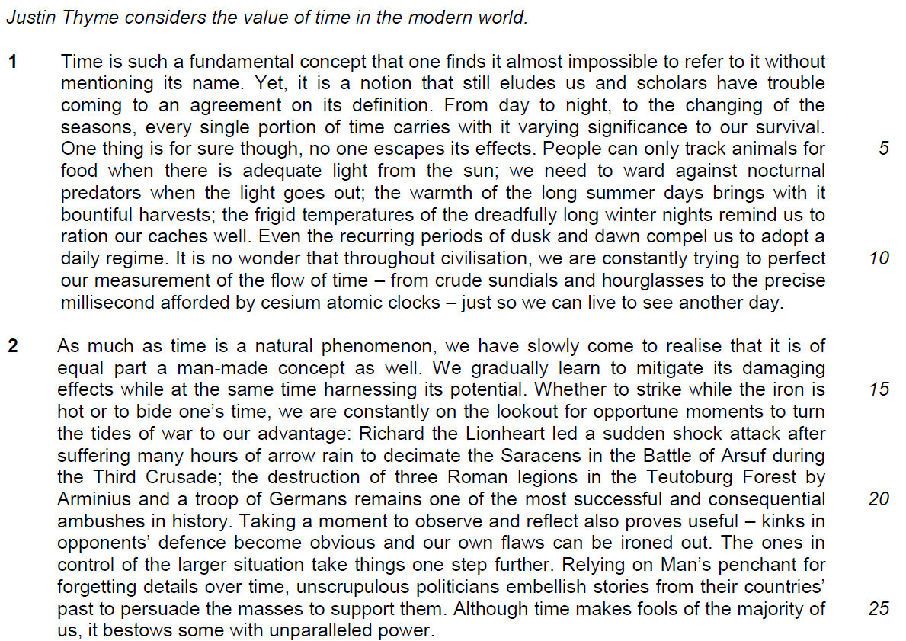

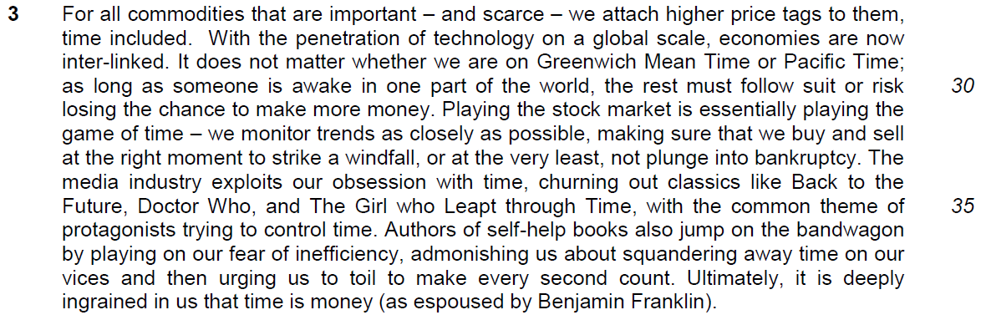

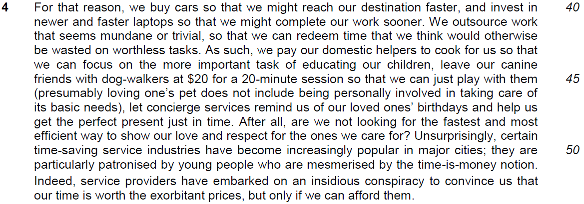

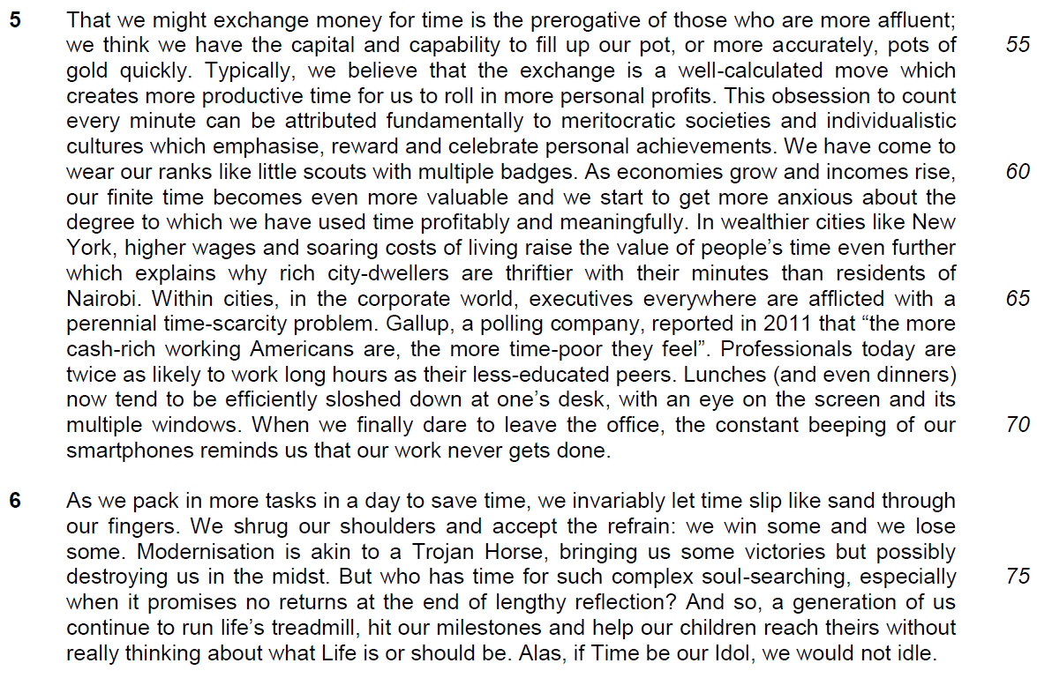

Read the passages in the insert and then answer all the questions. Note that up to fifteen marks will be given for the quality and accuracy of your use of English throughout this paper.

NOTE: When a question asks for an answer IN YOUR OWN WORDS AS FAR AS POSSIBLE and you select the appropriate material from the passage for your answer, you must still use your own words to express it. Little credit can be given to answers which only copy words and phrases from the passages.

Q1) Explain the irony in lines 1 – 3. [1]

……………………………………………………………………………………………………………………………………
……………………………………………………………………………………………………………………………………

Q2) In the first paragraph, explain the effects of time on our survival. Use your own words as far as possible. [3]

……………………………………………………………………………………………………………………………………
……………………………………………………………………………………………………………………………………

……………………………………………………………………………………………………………………………………
……………………………………………………………………………………………………………………………………

……………………………………………………………………………………………………………………………………
……………………………………………………………………………………………………………………………………

Q3) Explain how the examples given in lines 15–21 show the ways we can turn the tides of war to our advantage. [2]

……………………………………………………………………………………………………………………………………
……………………………………………………………………………………………………………………………………

……………………………………………………………………………………………………………………………………
……………………………………………………………………………………………………………………………………

Q4) Suggest two reasons why the author compares playing the stock market to playing the game of time in lines 31–33. [2]

……………………………………………………………………………………………………………………………………
……………………………………………………………………………………………………………………………………

……………………………………………………………………………………………………………………………………
……………………………………………………………………………………………………………………………………
Q5) In paragraph 5, explain why the author thinks that those who are more affluent are more likely to exchange money for time. Use your own words as far as possible. [3]

……………………………………………………………………………………………………………………………………
……………………………………………………………………………………………………………………………………

……………………………………………………………………………………………………………………………………
……………………………………………………………………………………………………………………………………

……………………………………………………………………………………………………………………………………
……………………………………………………………………………………………………………………………………

Q6) What is the significance of the word ‘typically’ in line 56? [1]

……………………………………………………………………………………………………………………………………
……………………………………………………………………………………………………………………………………

Q7) In paragraph 5, what differences are there between life in New York and Nairobi? Use your own words as far as possible. [2]

……………………………………………………………………………………………………………………………………
……………………………………………………………………………………………………………………………………

……………………………………………………………………………………………………………………………………
……………………………………………………………………………………………………………………………………

Q8) What does the phrase ‘run life’s treadmill’ in line 77 suggest about how we live our life? [1]

……………………………………………………………………………………………………………………………………
……………………………………………………………………………………………………………………………………

Q9) Suggest why the author uses the sentence ‘Alas, if Time be our Idol, we would not idle’ in line 78. Use your own words as far as possible. [2]

……………………………………………………………………………………………………………………………………
……………………………………………………………………………………………………………………………………

……………………………………………………………………………………………………………………………………
……………………………………………………………………………………………………………………………………

Summary Question
Q10) Using material from paragraphs 3–4 only, summarise the ways in which time is associated with monetary value.

Write your summary in no more than 120 words, not counting the opening words which are printed below. Use your own words as far as possible. [8]

We place monetary value on time because …

 | Lifted | Paraphrased
a | For all commodities that are important – and scarce – we attach higher price tags to them, time included.
b | With the penetration of technology on a global scale, economies are now inter-linked.
c | as long as someone is awake in one part of the world, the rest must follow suit
d | or risk losing the chance to make more money.
e | Playing the stock market is essentially playing the game of time… we monitor trends as closely as possible,
f | making sure that we buy and sell at the right moment to strike a windfall, or at the very least, not plunge into bankruptcy.
g | The media industry exploits our obsession with time,
h | churning out classics… with the common theme of… trying to control time.
i | Authors of self-help books… (play) on our fear of inefficiency,
j | admonishing us about squandering away time on our vices
k | and then urging us to toil to make every second count.
l | Ultimately, it is deeply ingrained in us that time is money
m | we buy cars .. and invest in newer and faster laptops

 | Lifted | Paraphrased
n | so that we might reach our destination faster… so that we might complete our work sooner/ looking for the fastest and most efficient way
o | We outsource work that seems mundane or trivial,
p | so that we can redeem time that we think would otherwise be wasted on worthless tasks.
q | are we not looking for the fastest and most efficient way to show our love and respect for the ones we care for?
r | certain time-saving service industries have become increasingly popular in major cities;
s | service providers have embarked on an insidious conspiracy to convince us
t | that our time is worth the exorbitant prices, but only if we can afford them.

Application Question
Q11) In this article, Justin Thyme shares his observations on how the modern world views time. How valuable is time to you and your society?
[10]

……………………………………………………………………………………………………………………………………
……………………………………………………………………………………………………………………………………

……………………………………………………………………………………………………………………………………
……………………………………………………………………………………………………………………………………

……………………………………………………………………………………………………………………………………
……………………………………………………………………………………………………………………………………

……………………………………………………………………………………………………………………………………
……………………………………………………………………………………………………………………………………

……………………………………………………………………………………………………………………………………
……………………………………………………………………………………………………………………………………

……………………………………………………………………………………………………………………………………
……………………………………………………………………………………………………………………………………

……………………………………………………………………………………………………………………………………
……………………………………………………………………………………………………………………………………

……………………………………………………………………………………………………………………………………
……………………………………………………………………………………………………………………………………

……………………………………………………………………………………………………………………………………
……………………………………………………………………………………………………………………………………

……………………………………………………………………………………………………………………………………
……………………………………………………………………………………………………………………………………

……………………………………………………………………………………………………………………………………
……………………………………………………………………………………………………………………………………

……………………………………………………………………………………………………………………………………
……………………………………………………………………………………………………………………………………

……………………………………………………………………………………………………………………………………
……………………………………………………………………………………………………………………………………

……………………………………………………………………………………………………………………………………
……………………………………………………………………………………………………………………………………

……………………………………………………………………………………………………………………………………
……………………………………………………………………………………………………………………………………

……………………………………………………………………………………………………………………………………
……………………………………………………………………………………………………………………………………

……………………………………………………………………………………………………………………………………
……………………………………………………………………………………………………………………………………

……………………………………………………………………………………………………………………………………
……………………………………………………………………………………………………………………………………

……………………………………………………………………………………………………………………………………
……………………………………………………………………………………………………………………………………

……………………………………………………………………………………………………………………………………
……………………………………………………………………………………………………………………………………

……………………………………………………………………………………………………………………………………
……………………………………………………………………………………………………………………………………

……………………………………………………………………………………………………………………………………
……………………………………………………………………………………………………………………………………

……………………………………………………………………………………………………………………………………
……………………………………………………………………………………………………………………………………

……………………………………………………………………………………………………………………………………
……………………………………………………………………………………………………………………………………

……………………………………………………………………………………………………………………………………

