Comprehension Skills – Types of questions and Answering Skills.

The types of question under the SAQ section consists of the following types of question:

- Factual-based type of question
- Language-Application type of question
- Language-Inference type of question
- Inference-based type question
- Literacy device type of question
Features of the types of question

- Factual- based type of question
The requirement of the questions that deal with factual information that need students to explain the reasons, process and impact of the features of the subjects in creating the effects. The marks allocated to these questions are more than one mark.

- Language-Application type of the question tests the students’ capabilities to understand how the words are used to explain the ideas the writer is depicting in the passage.

- Language-inference type of question requires students to answer the purposes of the language application where students are to derive the intention, purpose, tone and attitude of the writer in using the words.

- Inference-based type of question requires students to depict the intended purpose of the writer in his or her expression from how he or phrases the development of his ideas, which may be rhetorical in expression and requires the students to figure out the inference.

- Literacy device type of question deals with special requirements on special literature language like oxymoron, ironic, parenthesis and paradoxes. All these language expressions explain how the writer makes the passage more interesting and complex and require the students to understand how it is formed and the purpose in setting them.
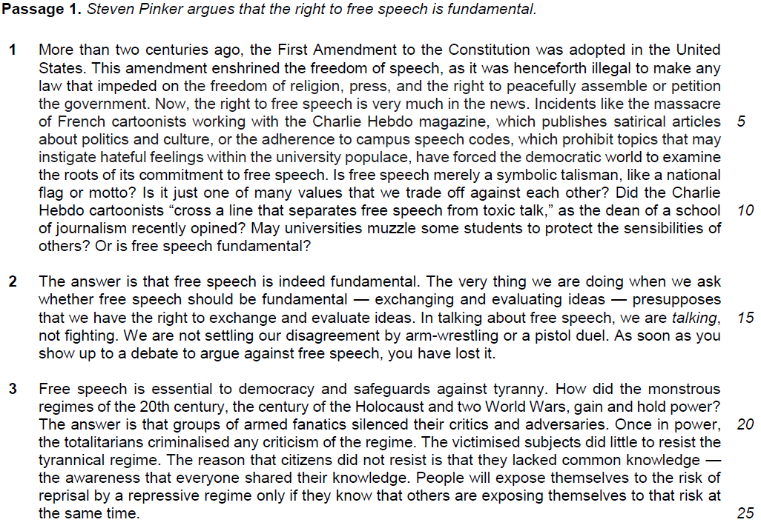1. What does the word “enshrined” (line 2) suggest about how Americans viewed freedom of speech? [1] (language-application)

…………………………………………………………………………………………………………………………
…………………………………………………………………………………………………………………………

2. Why has the author written the word “talking” in italics (line 15)? [1] (literacy device)

…………………………………………………………………………………………………………………………
…………………………………………………………………………………………………………………………

3. “As soon as you show up to a debate to argue against free speech, you have lost it” (lines 16−17).

Why does the author make this claim? Use your own words as far as possible. [3] (factual-based question – process explanation)

…………………………………………………………………………………………………………………………
………………………………………………………………………………………………………………………

…………………………………………………………………………………………………………………………
…………………………………………………………………………………………………………………………
…………………………………………………………………………………………………………………………
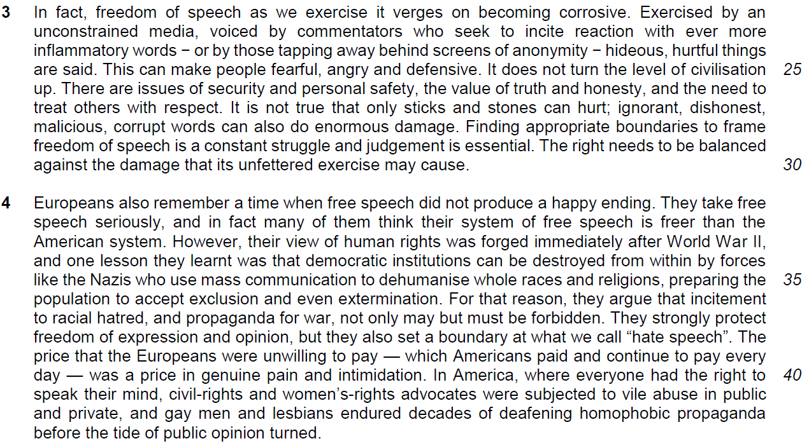

4. What “logic” is the author illustrating with the story of “The Emperor’s New Clothes” (line 26)? Use your own words as far as possible. [2] (inference- type )

………………………………………………………………………………………………………………………
…………………………………………………………………………………………………………………………

…………………………………………………………………………………………………………………………
…………………………………………………………………………………………………………………………

5. “humour is no laughing matter” (line 30). (literacy device)

Explain why this is a paradox. Use your own words as far as possible. [3]

…………………………………………………………………………………………………………………………
…………………………………………………………………………………………………………………………

…………………………………………………………………………………………………………………………

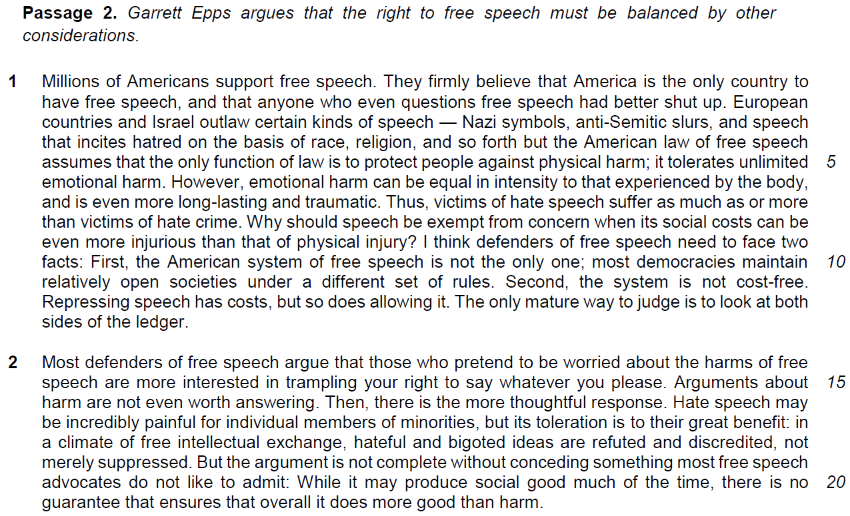

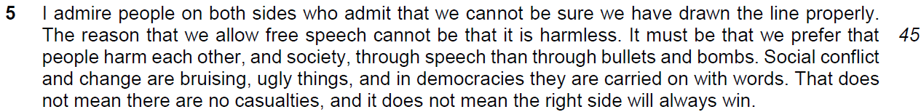

From Passage 2

6. Explain the author’s use of the word “even” in the phrase “anyone who even questions free speech” (line 2). [2] (language application)

………………………………………………………………………………………………………………………
…………………………………………………………………………………………………………………………

…………………………………………………………………………………………………………………………
…………………………………………………………………………………………………………………………

7. How do the victims of hate speech suffer “more than” (lines 7−8) the victims of hate crime? Use your own words as far as possible. [1] (language application)

…………………………………………………………………………………………………………………………
…………………………………………………………………………………………………………………………

8. Based on lines 14−16, what does the author suggest about how most defenders of free speech view those who argue against it? [2] (factual – process)

…………………………………………………………………………………………………………………………
…………………………………………………………………………………………………………………………

…………………………………………………………………………………………………………………………
…………………………………………………………………………………………………………………………

9. What was the price of free speech that the Europeans were “unwilling to pay” (line 39)? Use your own words as far as possible. [2] (factual – features)

…………………………………………………………………………………………………………………………
………………………………………………………………………………………………………………………

……………………………………………………………………………………………………………………………………………………………………………………………………………………………………………………

